Lecture 1

# What is artificial intelligence?

* Is a simulation of human intelligence processes by machines
* A method of making a computer act intelligently like the human mind
* Performing tasks which require “intelligence” (Image recognition, speech, creative processes)

All ai falls into four different categories

|  |  |
| --- | --- |
| Acting humanly | Acting rationally |
| Thinking humanly | Thinking rationally |

* To act humanly means that it can past the turing test approach (if the computer can pass an interrogation by another human without the human realising it is an computer). This kind of AI is mostly found in chat bots and human interaction with an AI. To classify as acting humanly, an AI which acts humanly it has to possess NLP; Knowledge representation; automated reasoning; and a learning capability
* Thinking humanly is cognitive modelling, systems which solve problems the same way humans do. Analysing, Planning, Executing etc. Problem solving
* Thinking rationally, the use of logic. Systems capable of reasoning, capable of making logical deductions from a knowledge base
* Acting rationally entails the ai being a rational agent. A rational agent will try to maximize the expected value of their performance measure given their current knowledge.

# When to use AI

* AI algorithms are needed for tasks which are too unruly for humans but too complex for a simple algorithm to solve.
* AI can process far more data than a human, thus, when dealing with big data, an AI is suitable.
* Analysing data with multiple dimensions
* Timeseries data analysis when a lot of data points are at play

Lecture 2

# Agents in AI

* A computer software system that can make decisions based on their environment, user input and experiences. An intelligent agent should act independently.
* Has different sensory inputs (cameras microphone etc)
* An agent interacts with the environment. Actuators are used to convey the output.
* The agent function maps from its sensors to actions which can be represented with a function f
* The agent program runs on some physical architecture to produce the function f
* An agent in general terms is architecture + program.

A human can be considered an agent in the sense that our body/brain is the architecture whilst our instincts are the software. Our sensors are our eyes ears taste nose etc. A software agent’s code is the program whilst its run environment is the architecture.

## Rational agents

A rational agent strives to “do the right thing”, based on what it can perceive and the actions it can perform. The right action is the one that will cause the agent to be most successful. Performance measures are used to determine what is the right thing (an objective criterion for success of an agent’s behaviour).

Eg. Performance measure of a vacuum-cleaner agent could be amount of dirt cleaned up, amount of time taken, amount of electricity consumed, amount of noise generated, etc.

For each possible percept sequence a rational agent should select an action that is expected to maximize its performance measure, given the evidence provided the percept sequence and whatever preprogramed knowledge the agent has.

Rationality is not omniscience (all-knowing with infinite knowledge). A rational agent acts based on limited knowledge. Agents can perform actions in order to modify future precepts so as to obtain useful information.

## PEAS

Performance measure, environment, actuators, sensors.

When creating an ai, you must always specify the setting for your intelligent agent design.

**Examples:**

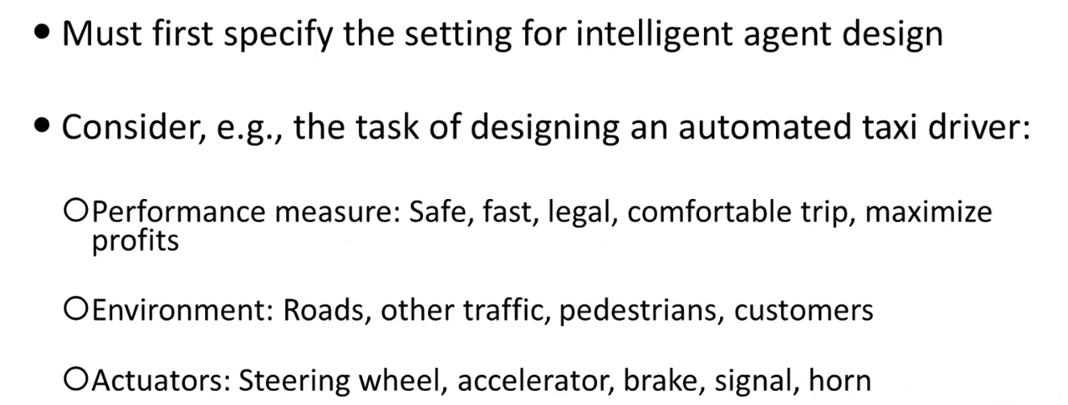

* Sensors: cameras, sonar, speedometer, gps, engine sensors, keyboard

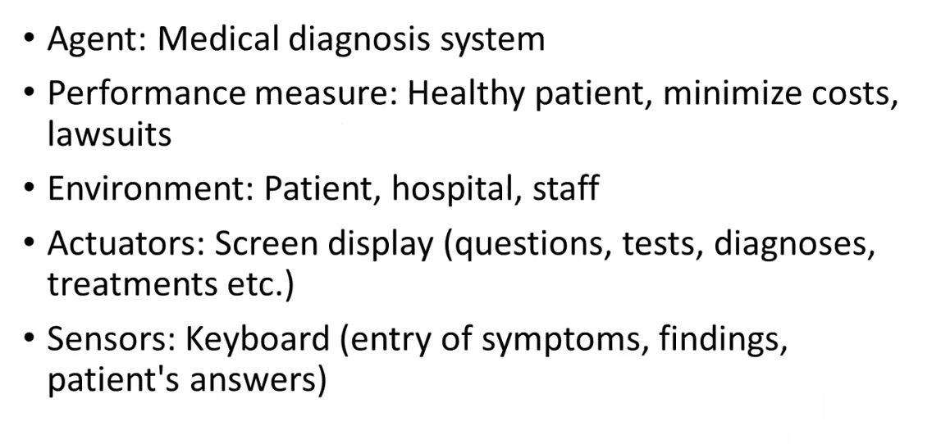

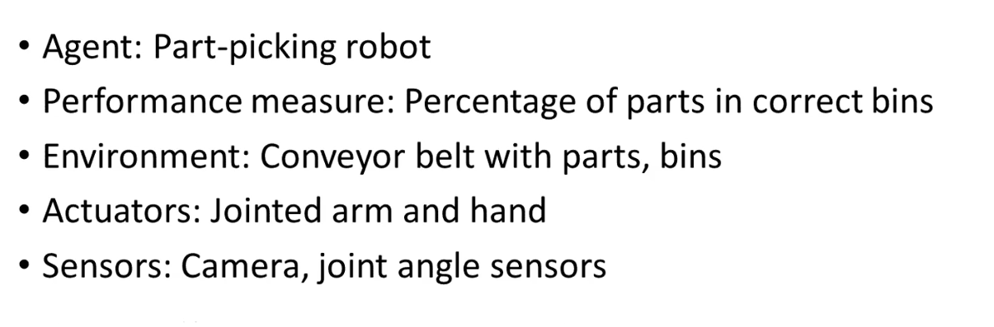

## Environment Types

* **Fully observable** (vs partially observable): An agent’s sensors give it access to the complete state of the environment at each point in time. A partially observable environment could be seen as a city with a self driving car. The car only knows the state of the street ahead.
* **Deterministic** (vs. stochastic): The next state of the environment is completely determined by the current state and the action executed by the agent. (If the environment is deterministic, except for the actions of other agents then it is strategic).
* **Episodic** (vs. sequential): The agent’s experience is divided into atomic episodes ( each episode consists of the agent perceiving and then performing a single action), and the choice of action in each episode depends only on the episode itself.
* **Static** (vs dynamic): The environment is unchanged while an agent is deliberating.
* **Discrete** (vs continuous). A limited number of distinct, clearly precepts and actions.
* **Single agent** (vs. multiagent): an agent operating by itself in an environment.

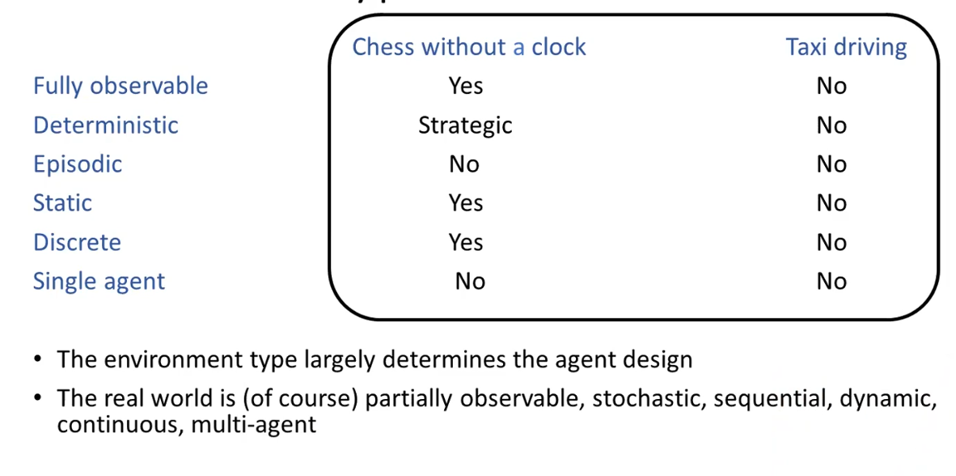

## Agent types

### Simple reflex agents

Perceives the environment -> does an action based on its input

### Model based reflex agents

It looks at the state of the environment-> does an action based on its input-> stores the result in order to skip repetition -> repeat. No goals are defined.

### Goal based agents

Checks the environment –> considers how the environment will change based on the actions available-> chooses the action which suits its goals-> stores the result-> repeat. Goals defined.

### Utility based agents

Same as goal based, but user satisfaction of said action is considered. Goals defined which are modified by user input.

# Knowledge representation and reasoning

Knowledge plays as vital role in intelligence as well as creating artificial intelligent

It demonstrates intelligent behaviour in AI agents.

Knowledge representation is the study of how knowledge and facts about the world can be represented and what kinds of reasonings can be done with that knowledge.

The representation should be rich enough to express the knowledge needed to solve the problem

Compact natural and maintainable, amenable to efficient computation

Able to express features

Able to be used for trade off accuracy and computation time.

## Cycle of knowledge representation

The **perception** **component** retrieves data or information from the environment. The **learning** **component** that learns from captured data by the perception component. The goal is to build computers that can be taught In order to learn new things, the system requires knowledge acquisition inference, acquisition of heuristics, faster searches etc

# Logic

## Propositional logic

The simplest kind of logic, in which all statements are made of propositions which are either true or false. E.g., 2+2=4 eller Karlskrona är I Kinesiska folkrepubliken.

Propositional logic is not expressive enough

## First order logic

Tänk problemlösningen

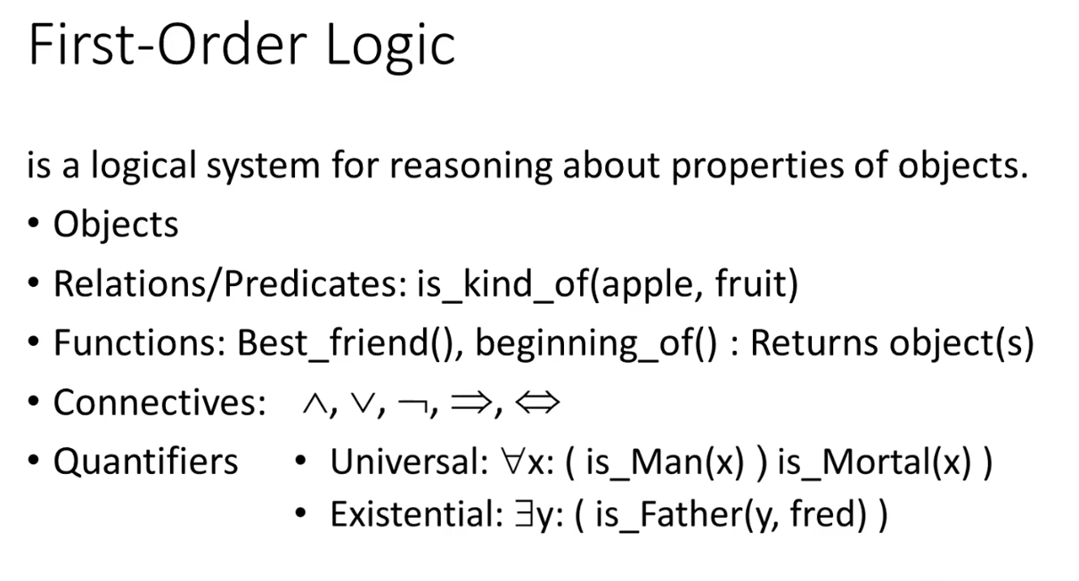

## Other logics

Fuzzy logic

Lecture 3

# What is a graph?

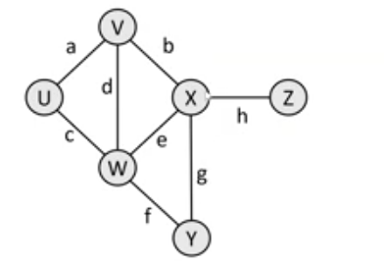A graph is a data structure containing:

* A set of vertices V
* A set of edges E, wjere am edge represents a connection between 2 vertices
  + Graph G (V, E)
  + An edge pair is (v,w) where v,w are in V
  + Edges can be directed or non directed.

## Paths

a path from a vertex a to b is a sequence of edges that can be followed starting from a to reach b. It can be either represented as vertices visited or edges taken.

The number of vertices or edges contained in the path is called **path length**

A vertex can be considered to be a neighbour or adjacent when it is connected to another node directly by an edge

## Reachability

**Reachable**: a path between a and b exists

**Connected**: a graph in which every vertex can be reached from any starting point

**Strongly connected**: every vertex is a neighbour

## Loops and cycles

**Cycle:** a path that begins and ends at the same node

**Acyclic graph**: a graph which does not contain any cycles

**Loop**: an edge which is starts and ends at the same node

* + Many graphs do not allow for loops

## Weighted graphs

**Weight**: a cost associated with a given edge

* Some graphs have weighted edges
* Edges in an unweighted graph can be thought of having an equal weight
* Most graphs do not allow negative weights

# Solving problems by searching

## Problem solving agents

Agents whose task it is to solve a particular problem. The agent knows the following things:

* What is the goal state
* What are important characteristics of the goal state
* Knows when it has reached the goal
* If there are several possible goals

## Problem types

* Finding any path (or wanting to know whether there is a path)
* Minimize path length (number of edges traversed)
* Minimising path cost (sum of edge weights)
* Finding all solutions to a problem

## Problem formulations

What are the possible states of the world relevant for solving the problem

what information is accessible to the agent

How can the agent progress from state to state

The problem has to be well defined. The initial state, the actions path and goal test have to be specified

## Example problems

Bucharest problem

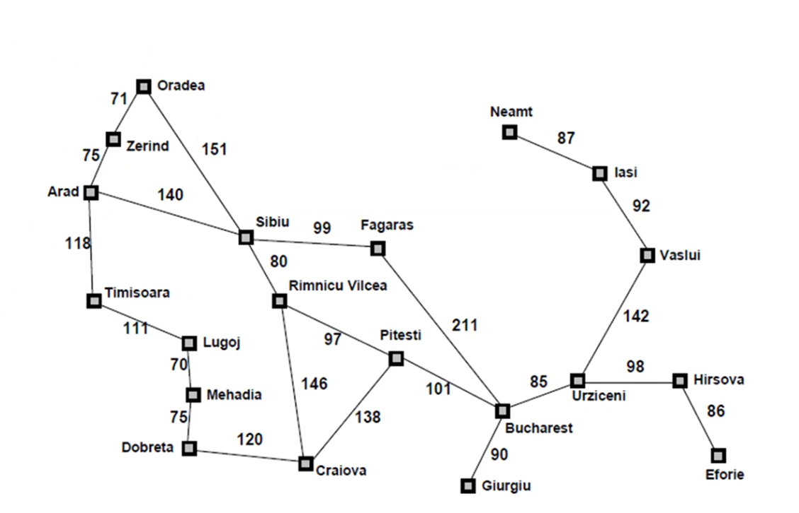

The goal is to traverse from Arad to Bucharest with the lowest possible cost.

# Types of search algorithms

## Uninformed search

Also called blind search, uninformed search algorithms are a general-purpose search algorithm which brute force their way through a problem. They do not require additional information about the state or search space. Generates the search tree without using any domain specific knowledge.

### Depth first search algorithm

DFS finds a path between two vertices by exploring each possible path as far as possible before backtracking

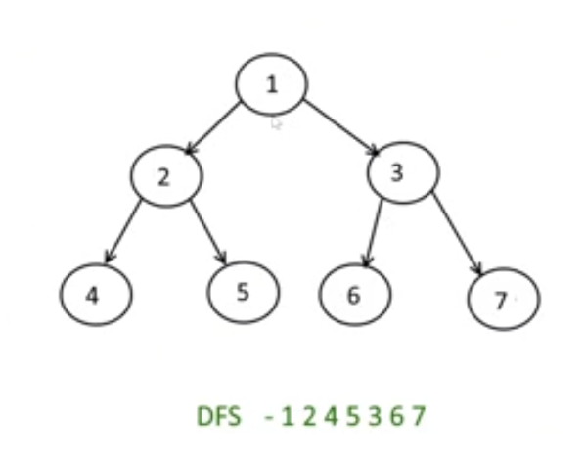Steps:

1. Start at the root node and push it onto the stack
2. Check for any adjacent nodes of the tree and select one node
3. Traverse the entire branch of the selected node and push all nodes into the stack
4. Upon reaching the end of a branch the n:th node, move back by a single step and look for adjacent nodes of the n-1th node.
5. If there are adjacent nodes for the (n-1)th node traverse those branches and push nodes onto the stack

### Diagram Description automatically generatedBreadth search algorithm

BFS finds a path between two nodes by taking one step down all paths and then immediately back tracking

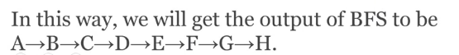BFS always returns the shortest path (the one with the fewest edges) between the start and the end vertices.   
BFS is a traversal technique in which we traverse all the nodes of the graph in a breadthwise motion. In bfs we traverse one level at a time and then jump to the next level. In a graph the traversal can start from any node and cover all the nodes level wise. The bfs algorithm makes use of a queue. BFS will always reach the final goal state which is not always the case for DFS.

BFS takes a lot of space in comparison to dfs.

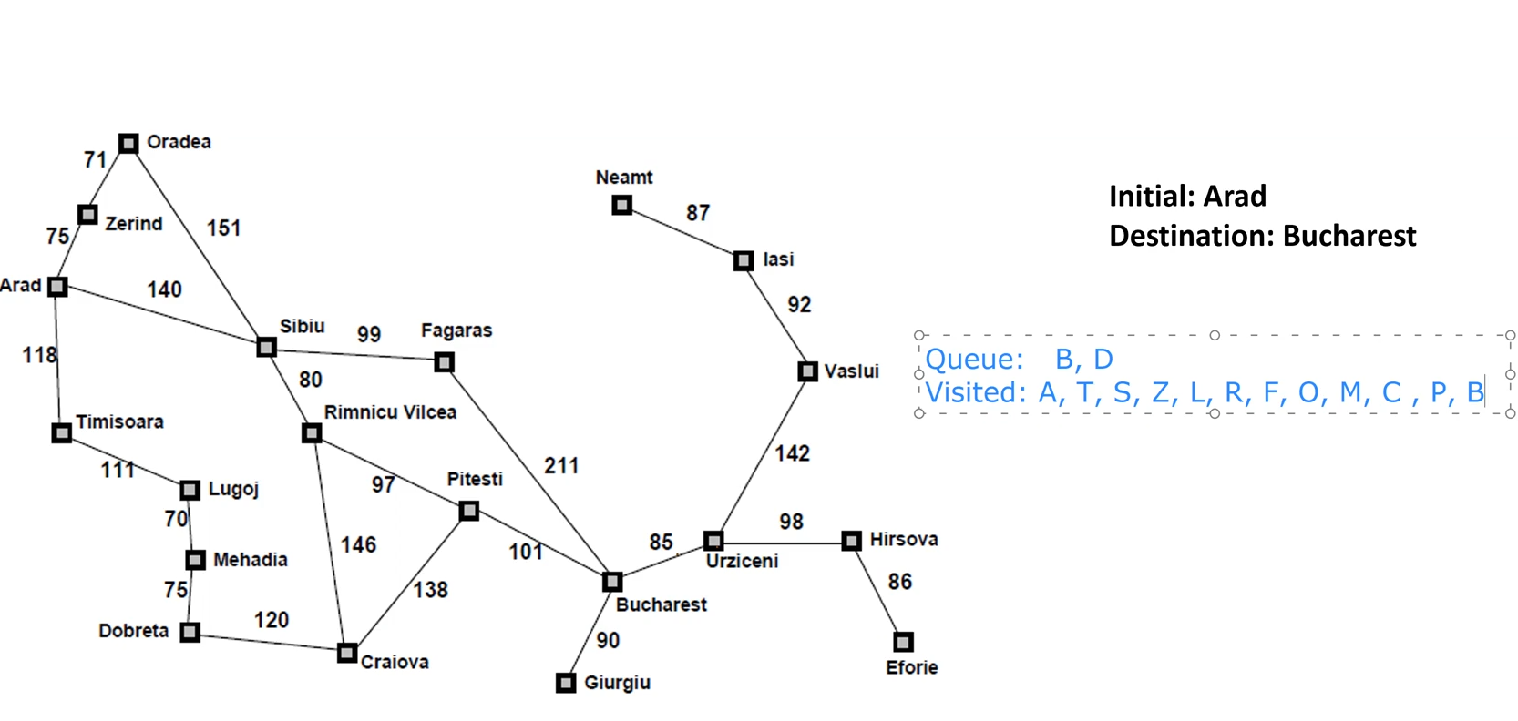

## Informed search

### Uniform cost search

Explores the cheapest node which hasn’t been explored yet. It is a variation of Dijkstra’s algorithm.

### Best-first search

This is an informed search technique (greedy) which is also called Heuristic search. This algorithm works using heuristic values by using an evaluation function to decide which adjacent node is the most promising. A priority queue is used to store cost of function.

### A* search algorithm

Is also best first, it does not consider how costly it was to get to another node

The main idea is to avoid expanding paths that are already expensive.

It combines the real values along with the heuristic values to decide which path to take

Lecture 4

# Evolutionary algorithm

Humans have evolved and continue to evolve over time. If we presume that prehistoric species of man were less fit for the environment. Creating a model which evolves would lead to improvements over generations.

This is the basis for evolutionary computing, the attempt at mimicking evolution.

## Genetic algorithms

In the early 70’s John Holland introduced the concept of genetic algorithms. It is typically applied to discrete (a finite number of solutions) optimisation problems. It is not the fastest algorithm, but it has good heuristics for combinatorial problems.

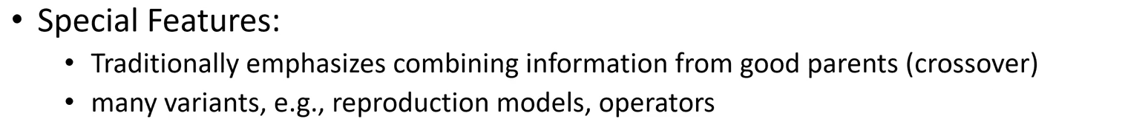

Its goal is to simulate life in order to solve the issues.

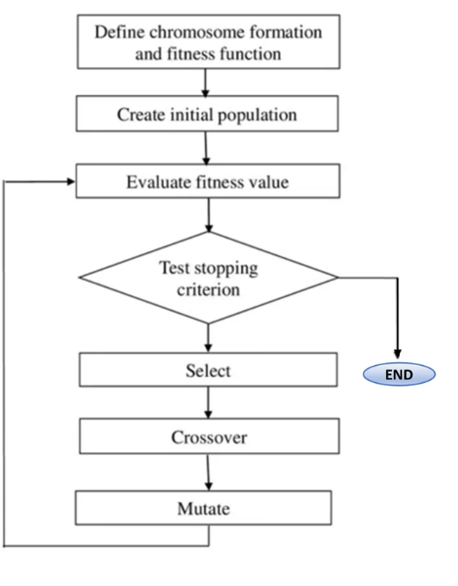A genetic algorithm can get stuck on local optimums.

Genetic Algorithms (GA) are a class of optimization algorithms where varied population evolved   
independently is mixed together to obtain a solution. GA consist of the following major steps:

1) Problem representation in a format usable by GA   
2) Computation of fitness value of the population   
3) Cross-over between the selected population based on the fitness scores   
4) Mutation of the generated population

### Components of GA

* A problem
* Encoding technique
* Initialization procedure
* Evaluation function
* Selection of parents
* Genetic operators
* Parameter settings

### Initial population

Consists of number of chromosomes or solutions

* Generated randomly
* A one time process
* The genes can be a set of binary numbers, real, numbers or anything

### Fitness function

Definition: Fitness function, evaluates how close a given solution is to the optimum solution of the desired problem.

The fitness function should quantitively measure how fit a given solution is in solving the problem.

The fitness function should be clearly defined, a reader should understand how it is calculated. There’s no universal fitness function, each problem requires its own specific fitness function.

### Evaluation function

The evaluator decodes a chromosome and assigns it a fitness measure. The evaluator is the link between GA and its problem.

### Operations

**Crossover** is a critical feature of genetic algorithms

* It greatly accelerates search early in evolution of a population
* It leads to effective combinations of sub solutions on different chromosomes.
* Single point crossover divides the genes of parents to create the next offspring. The cross over point is chosen randomly.

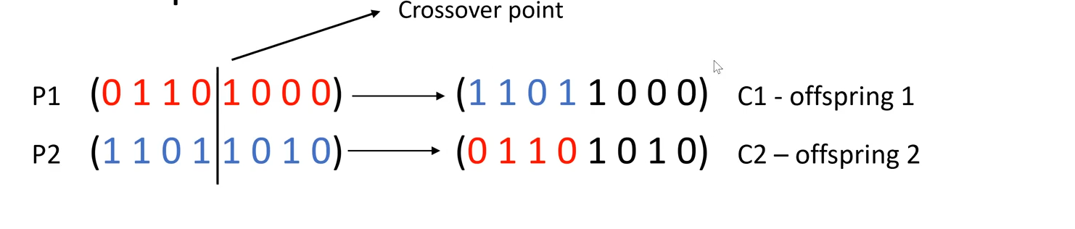

Two points cross over cuts the genes of the parents in two places and swaps the in between genes to create offspring.

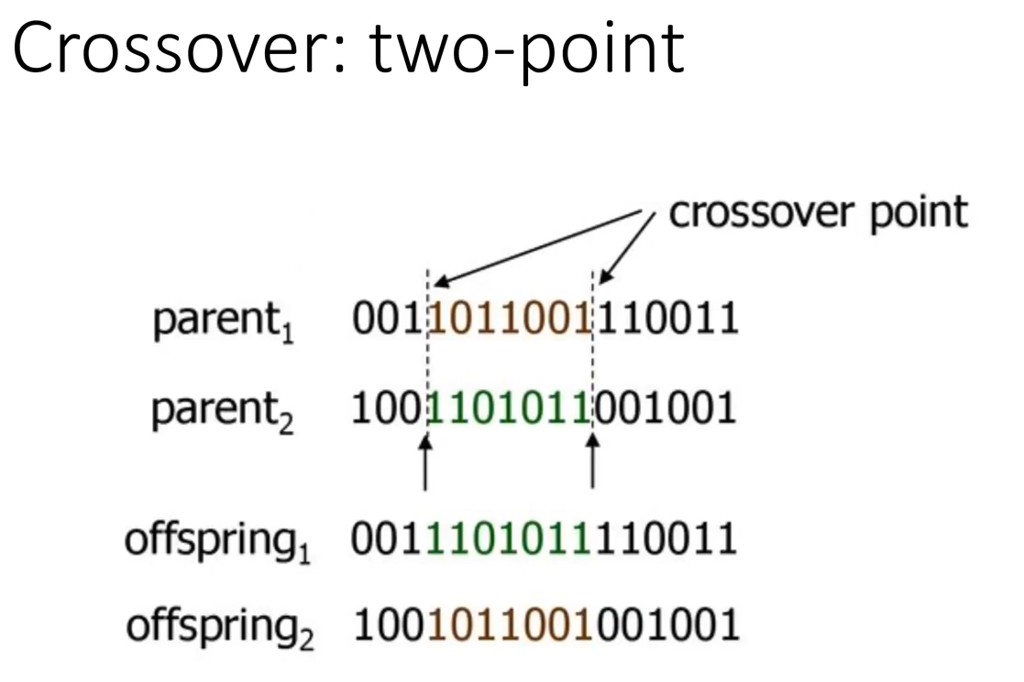

Parents and children are sometimes discarded since the population is always kept the same

**Mutation**

Mutations changes one of the chromosones randomly. This changes the fitness and is used to overcome a local optimum. It is a temporary operation which happens on offspring from a cross over. Mutation rate is usually low (1%-20%).

For continuous parameters, the mutated gene will be replaced by an arbitrary value.

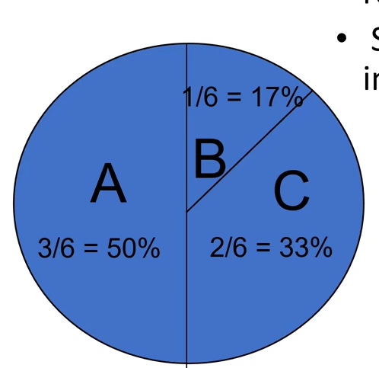

**Selection: Roulette wheel selection**

Main idea: More fit individuals get higher chance to survive.

* The chance is proportional to fitness
* Implementation: Assign each individual to a part of the roulette wheel
* Spin the wheel n-times to select n individuals to survive >:)

Lecture 5

# Data mining

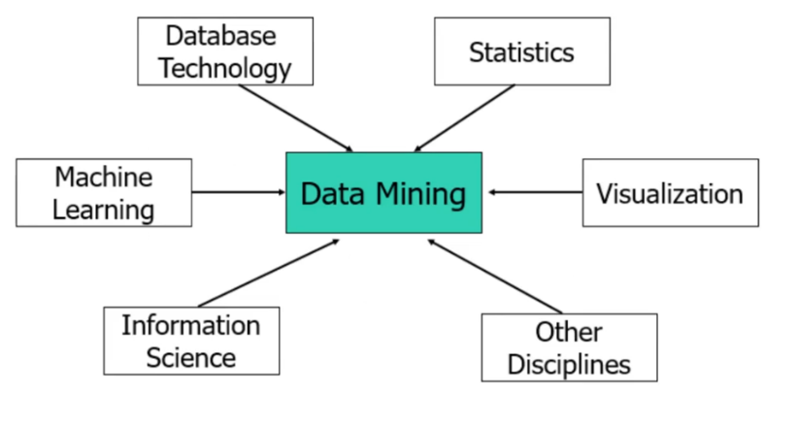Data mining is the process of extracting knowledge and insights from data.

The main steps of the data mining process are:

* Acquire and clean the data
* Extract valuable insights using ml
* Present and visual the gathered insights

Data mining is knowledge discovery from data. For it to be considered datamining it has to be the extraction of interesting patterns of knowledge from huge amount of data.

Data mining is mostly applied in areas of expertise.

There are several methods of datamining

## Diagram Description automatically generatedKDD

It is applied in many areas and can be applied to any datamining problem. KDD is considered a default method for any data science problem.

**Selection:** What kind of problem are we going to solve, define research question? Get the appropriate data

**Pre-processing**: Clean the data, format the data, get rid of noise

**Transformation**: Once we have pre-processed data, we apply dimension reduction or feature extraction methods to make the data more wieldable. The irrelevant attributes are removed.

**Datamining**: Selecting the technique used to get features. Understand the type of the problem, is it a clustering problem, classification, or prediction problem? Once we know this we apply a machine learning algorithm to get the useful information

**Intepretation:** Assess and evaluate the information given through the datamining process. Knowledge (useful) is the product of these steps.

**If a step is skipped or neglected, then the result will be affected detrimentally**. 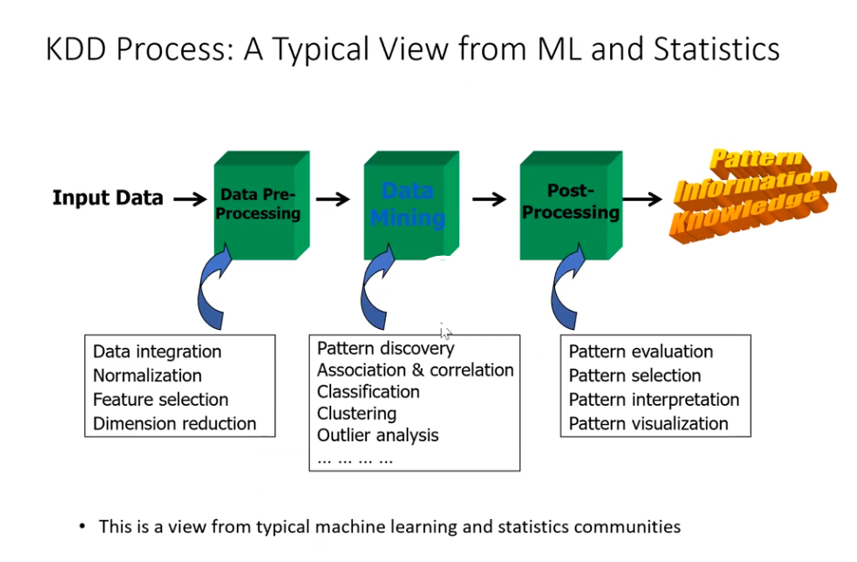

## Diagram Description automatically generatedCRISP-DM

Crisp is mostly applied in business. Unlike KDD, a customer exists which you’re working toward.

**Business understanding:** What kind of business are we intending on working on? What is the end goal?

**Data understanding**: Understand the data you work with.

**Data preparation**: Cleaning, dimension reduction etc

**Modelling**: Apply a model to do the datamining.

**Evaluation**: Assess and evaluate the information given through the datamining process. If you do not retrieve a useful result to the customer, you go back to trying to understand the work being done.

**Deployment**: If the customer accepts the result you can deploy-

This process is iterative, when something goes wrong in a step you go back and examine the previous step for mistakes. When modelling your solution, it is often normal to go back to data preparation and adapt your data to suit your model even further.

## OSEMN

**O**btain data

**S**crub data

**E**xplore data

**M**odel

I**n**terpret result

There is no transformation unlike KDD. Data exploration is a free form way of handling your data.

# Data

Data is a collection of objects and their attributes.

* An attribute is a property or characteristic of an object
  + Examples: Eye colour of a person, height
  + Attribute is also known as variable, field, characteristic or feature.
* A collection of attributes describes an object
  + Objects are also called, record, point, case, sample entity, or instance

Attribute values are numbers or symbols assigned to an attribute assigned to an attribute

The difference between attribute values and attribute:

* Same attribute can be mapped to different attribute values
  + Example: Height can be measured in feet or meters
* Different attributes can be mapped to the same set of values
  + Example: The attribute value for age and id is the same (int)
  + They have different maximum and minimum values

**Think datatype along with units for attribute values**

### Types of attributes

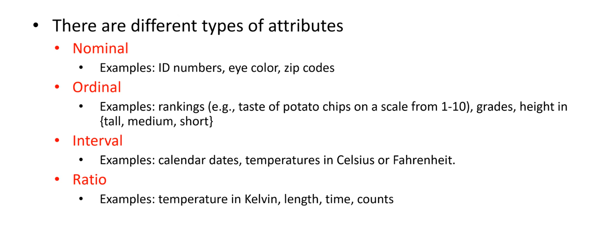

Jag har ingen aning om detta är rätt, när jag googlar så får jag andra resultat.

<https://www.freecodecamp.org/news/types-of-data-in-statistics-nominal-ordinal-interval-and-ratio-data-types-explained-with-examples/>

### Data quality

* What kinds of data quality problems?
* How can we detect problems with the data
* What can we do about these problems?

Examples of data quality problems are Noise, outliers, missing values, and duplicate data

### Data integration

Data integration is the combination of different data from multiple sources into a coherent store.

Schema integration

* Integration of metadata from different sources
* Entity identification problem: how to identify real world entities from multiple data sources. E.g A.cust-id ≡ b.cust-# (≡ means “identical to”)

Detecting and resolving data value conflicts

* For the same real-world entity, attribute values from different sources can be different
* Possible reasons to this are: different representations, different units (imperial vs metric)

Data integration is an important step in data mining as huge amounts of data are required to gather knowledge. Often, the data you have from one source is not enough and requires complementing data.

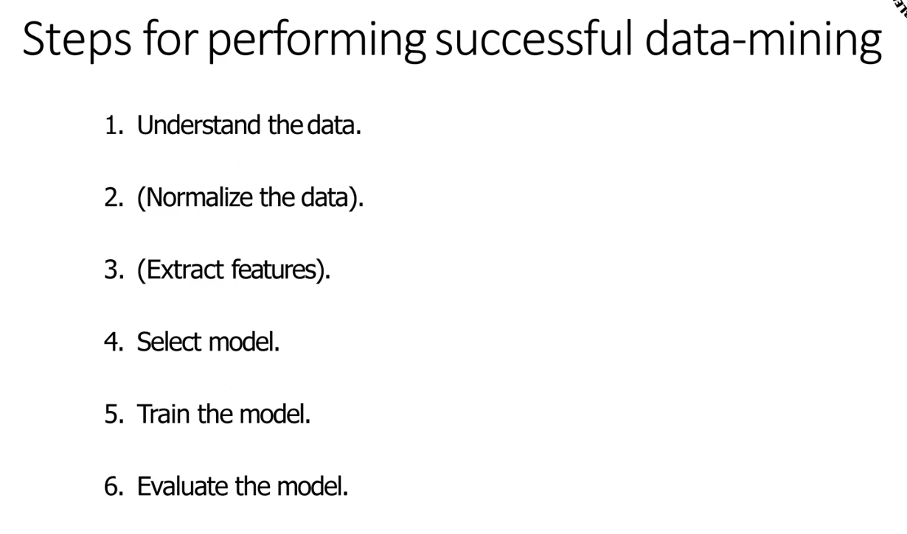

### Starting with data mining

All data science applications start with data. Therefore, if you want to be successful in data science you need to understand the data.

Q: Given the temperature over the last day could we predict the temperature for the next hour? Is this data indicative of future trends? Yes, it is possible, but a precise answer can’t be given as weather changes quickly.

Q: Given the number of ice-creams sold, could we predict the number of cars sold that day? Are they connected? Probably not, as knowledge about cars cannot be extracted from ice cream sales.

For the knowledge discovery to yield relevant results, our data has to be related to the field we’re studying

### Scale of the data

Data can be stored in formats with different scales. Temperature could for example be stored as the mean over a second, minute, day, week, month, or year. Picking the right interval and reducing redundancy is important.

Data can be aggregated to a form with a larger unit. For example, the mean daily temperature can be averaged into the mean weekly temperature.

How you scale the data depends on the end goal.

### Dimension reduction

The curse of dimensionality:

* The computational cost often grows quadratically with input size
* Data becomes increasingly sparse in the space it occupies

Lower the number of dimensions (but keeps as much of the variation/information as possible)

There are two techniques for dimension reduction. **Principal component analysis**(PCA) and **singular value decomposition** (SVD)

## Major tasks in data pre-processing

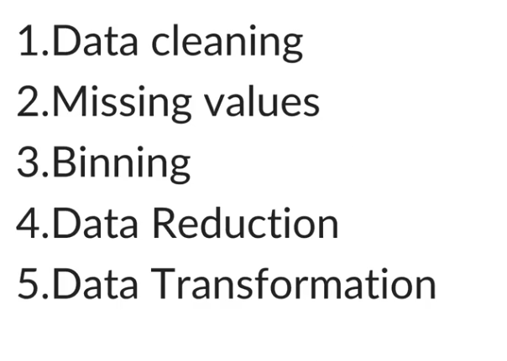

### Data cleaning

Data cleaning is the process where you remove incorrect data, incomplete data, inaccurate data from the datasets, and it also replaces the missing values. What it is replaced with varies greatly from set to set.

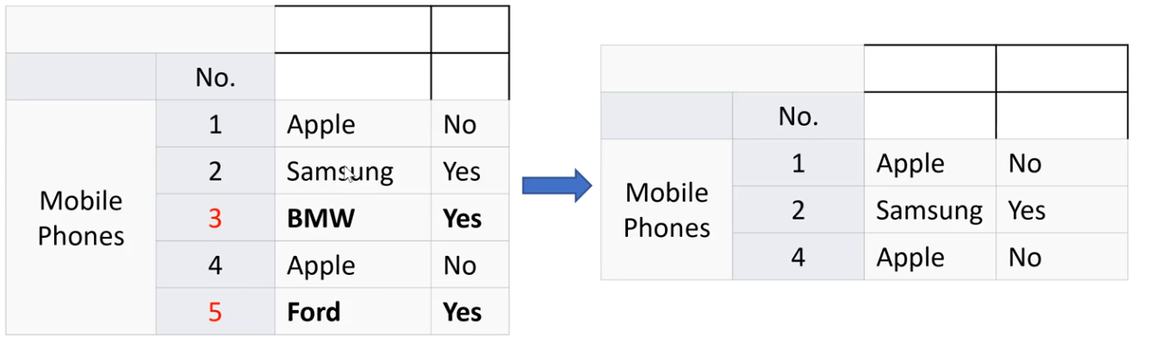

BMW and ford do not produce phones, removing the incorrect data makes the data cleaner

### Data editing

We can perform data editing and change incorrect values to correct ones if possible. Or randomly imputing one of the neighbours’ values.

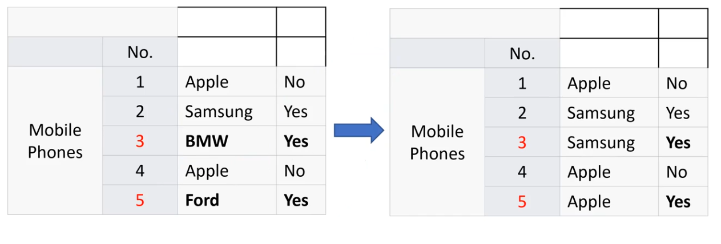 Let’s say ford works with apple and BMW with Samsung. Or that they were randomly imputed.

### Missing values

A very common problem is that the data set contains objects with missing values. It may have happened during data collection, or maybe due to some data validation rule, but regardless missing values need to be taken into consideration.

* Deleting rows with missing values
* Imputing missing values for categorical variable
* Prediction of missing values.

### Binning

Binning is when you categorize variables into discrete classes. Instead of describing ones length in cm you could instead group them into Tall kings (0), medium kings(1) and short kings (2) for example. This reduces the amount of space required.

### Normalization

It is often good to have similar values on all values

This can be done by normalization

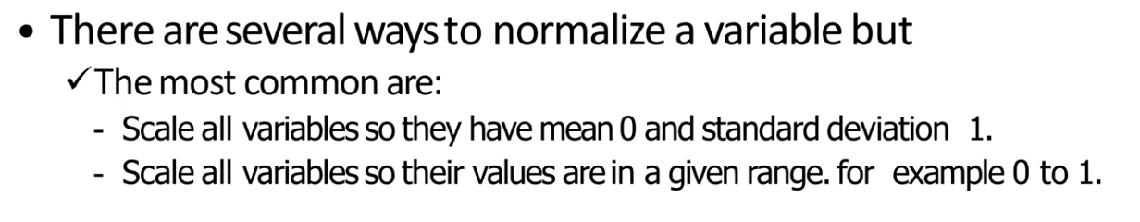

Removes the chance of one row dominating all other rows because it is big in absolute terms. If the data is normalised, the machine learning algorithm can effectively compare attributes.

# Data mining functions: Classification and prediction

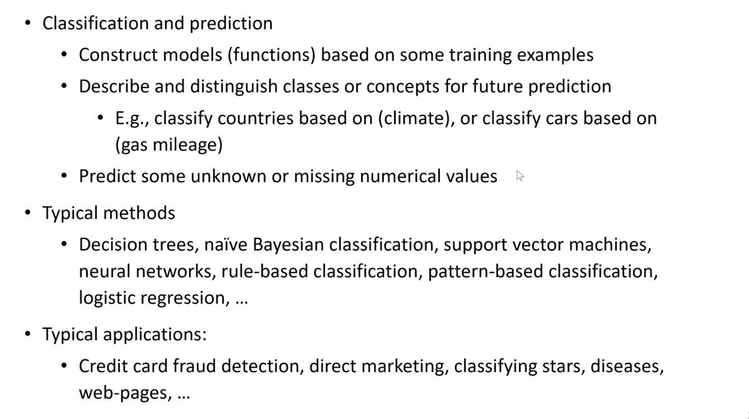

The goal of data classification is to organize and categorize data in distinct classes

* A model is first created based on data distribution
* The model is then used to classify new data
* Given the model, a class can be predicted for new data

## Classification

Training data is data with a correct label. We use training data to train the classification model. Once the model has been trained, it should be able to classify unlabelled data

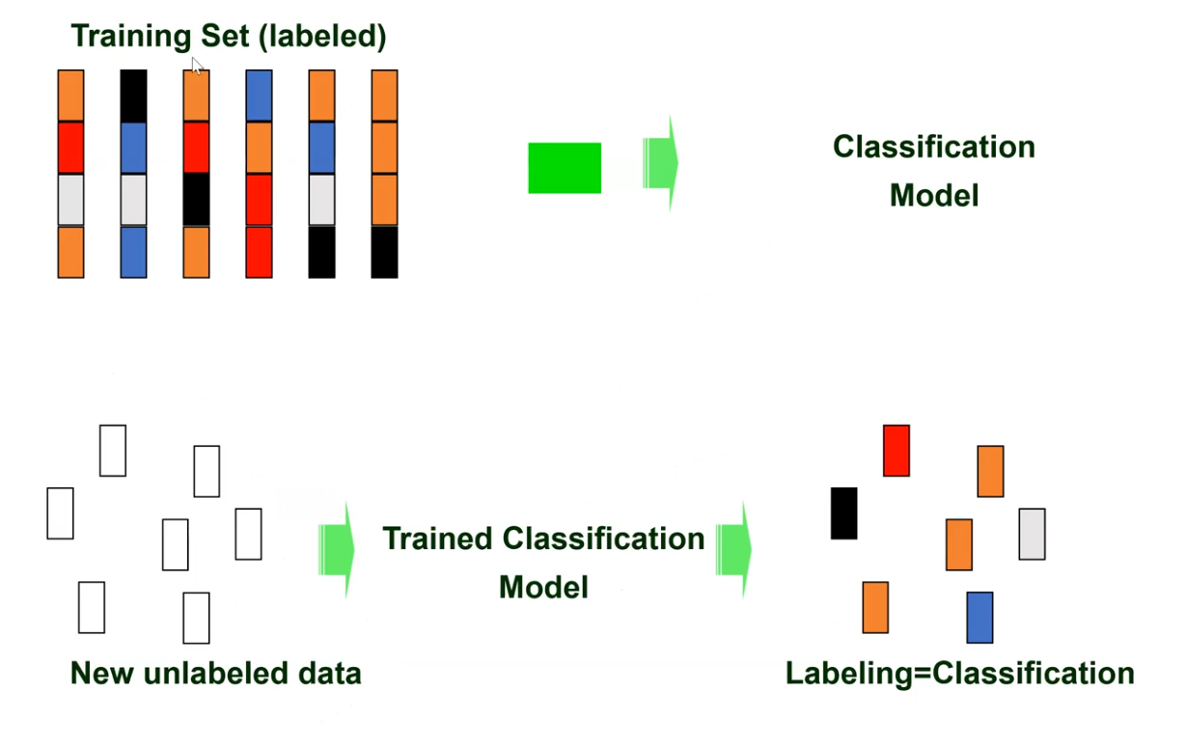

## Evaluation of model

After a result is obtained, we would like to know how good this result is. This is done by saving some of the data for evaluation. Split your labelled data into a training set and test set. Train the selected model with the training set. When the model is trained, we can test the model with the test data.

## Understanding the performance of the model

In order to understand when the performance of the model is good or it is important to understand the behaviour of the model. This can be done with a confusion matrix

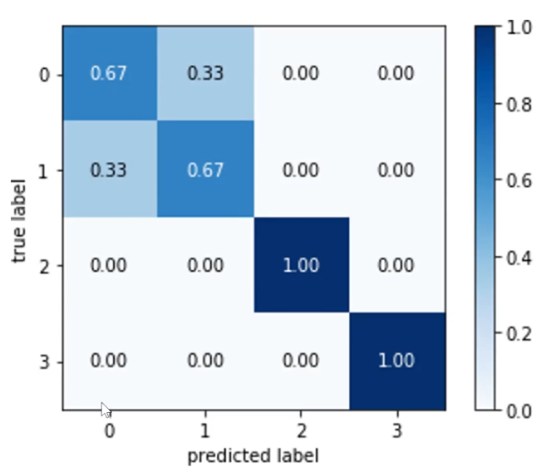

Translation: 0 is incorrectly identified as 1 with 33% certainty and vice versa with 1. Whilst 2 and 3 are correctly classified. Each row describes the spread of the classification. A perfect model would have a confusion matrix with 1:s on the diagonal.

There are many classifications methods

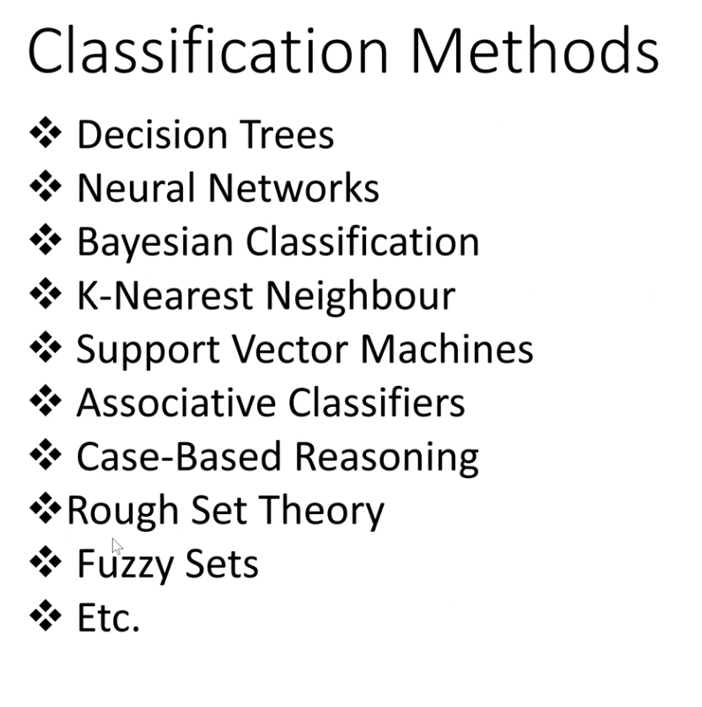

# Cluster and outlier analysis

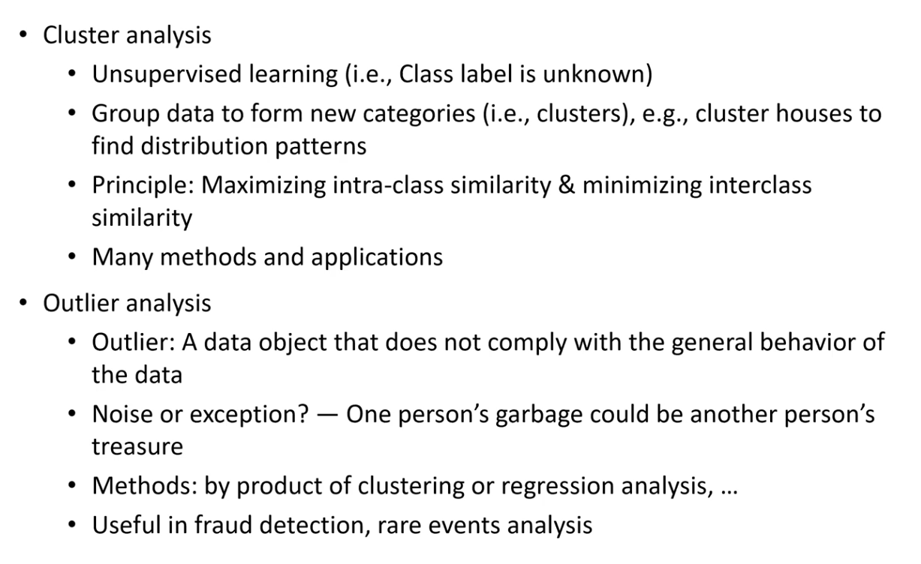

## Outlier detection

Finding exceptional data in various datasets and uncovering the implicit patterns of rare cases is outlier detection.

There are many reasons as to why an outlier may be present:

* Inherent variability – it possibly reflects reality
* Measurement error (inaccuracy and mistakes)

It is a field which has been studies for a long time and has only become more relevant with the advent of datamining. It has many applications from detecting credit card fraud to discovering criminal activities in e-commerce and identifying network intrusions.

Outliers are everywhere. Data values that appear inconsistent with the rest of the data are outliers.

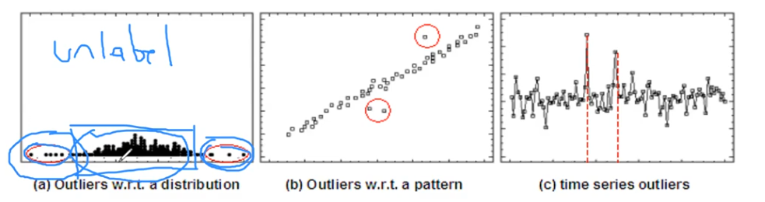

Can be clustered.

# Linear models

Linear models are referred to the geometric models. They can be used in n-dimensions but are commonly used when working with 2D or 3D. (A line in 2D, whilst a plane is used in 3D)

Geometric concepts such as lines and planes are used in this model to predict or simulate trends. Linear models are all a supervised based method. Linear models help us in finding the regression line which shows the relationship between 2 or more than 2 variables. A linear model can be used for classification and regression.

Classification is when our labels can only take a finite set of values (categories or classes) whilst a regression allows for the label to adopt any real continuous value.

Regressions are commonly used in the stock market, predicting sales, and detecting the age of a person from a picture.

## Creating a linear regression in 2D

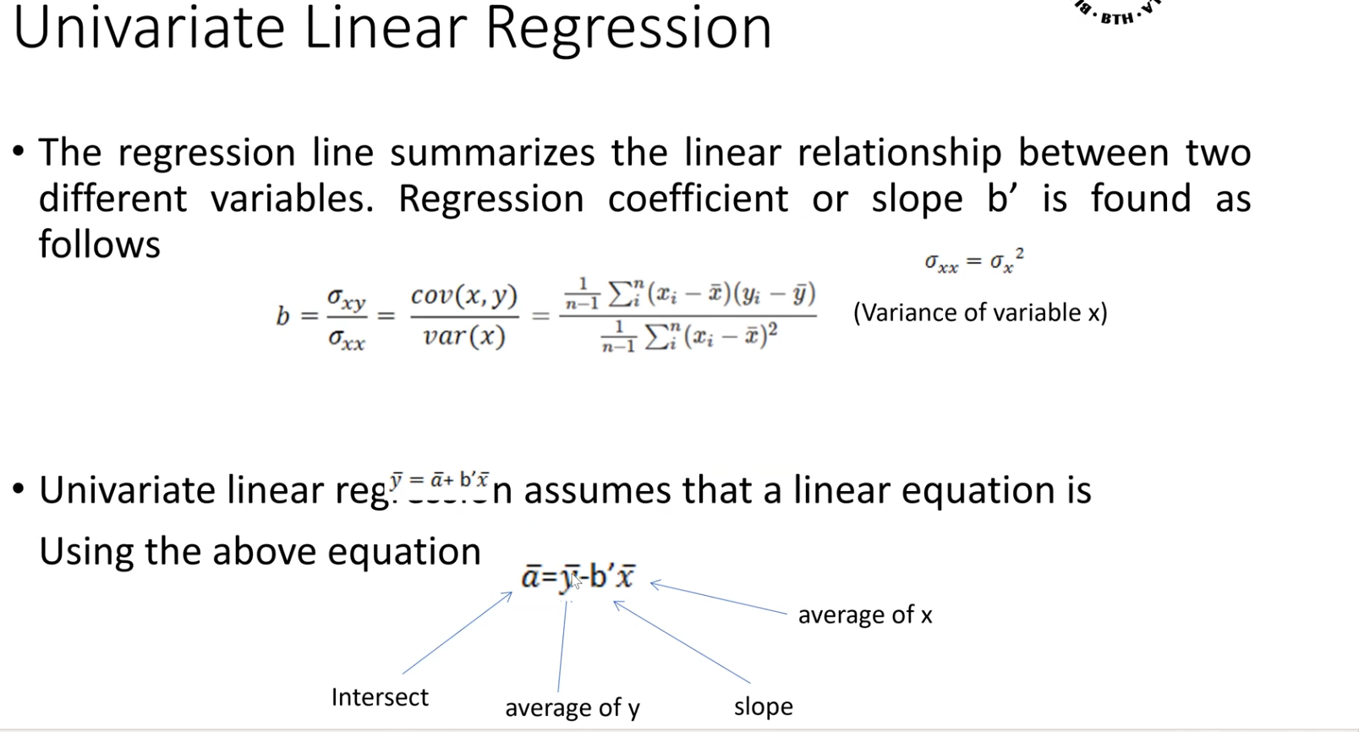

### Example:

Lets assume that the following input data is given

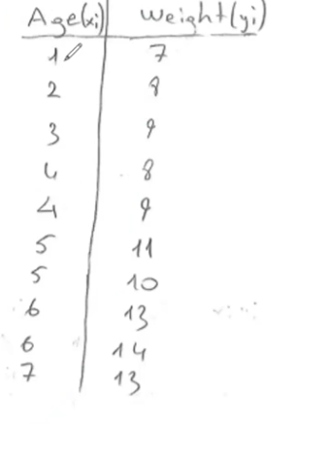 Find the regression line with respect to age

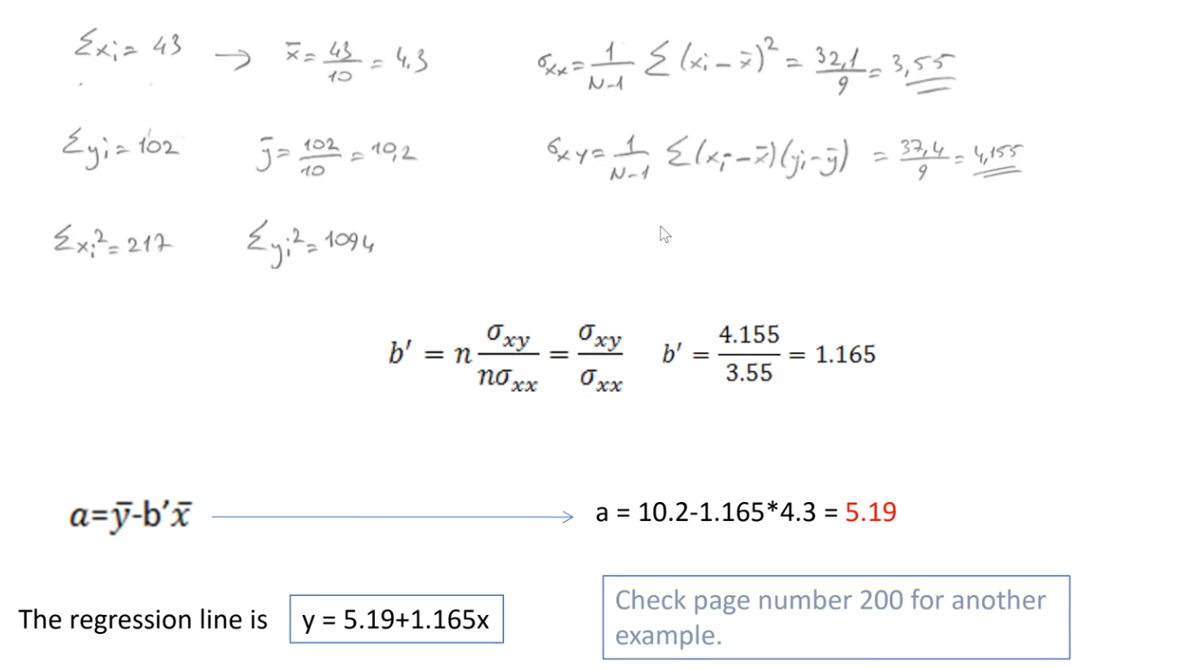

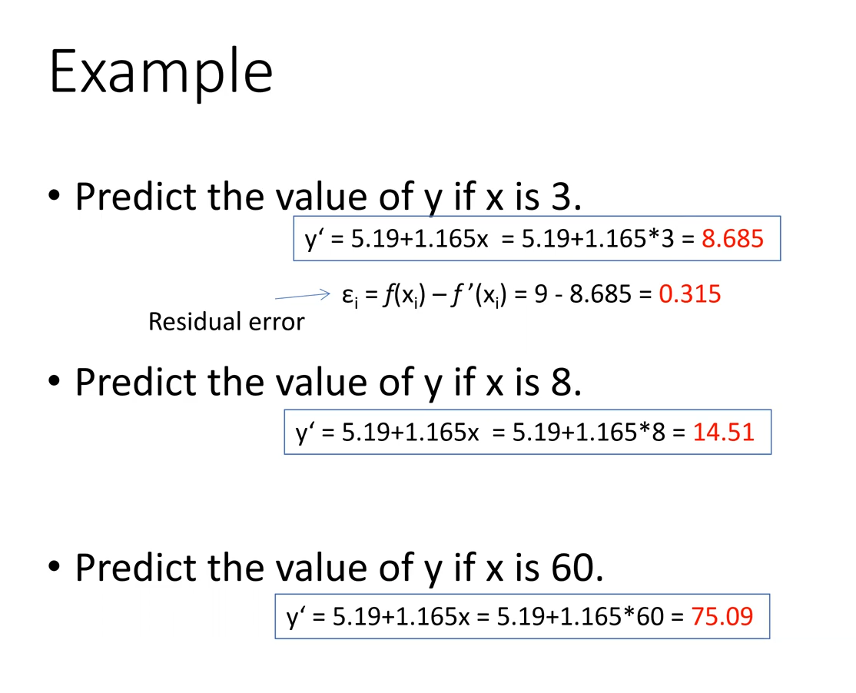

Lecture 6

# Machine learning

ML is a branch of AI. Uses computing-based systems to make sense out of data, extracting patterns, fitting data to functions, classifying data, etc.

ML systems have the ability to learn and improve based on historical data time and experience.

Bridges theoretical computer science and real data

Definition: machine learning is an application of artificial intelligence that involves algorithms and that automatically analyse and make decisions by itself without human intervention

### When to use ML?

ML is appropriate when:

* Human expertise does not exist (navigating on mars)
* Humans can’t explain their expertise (speech recognition)
* Models must be customized (personalised medicine)
* Models are based on an unruly amount data (genomics)

## Supervised learning

Supervised learning is divided into two categories

**Regression and Classification**

## Regression

Given a set of values, create a function f(x) to predict y given x. If y is real-valued = a regression

Example:

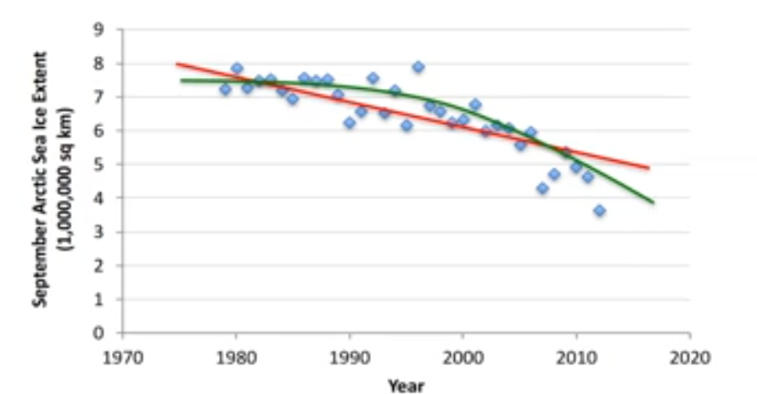

See previous lecture for specifics about linear regression.

### Non-linear regression models

Not all data follows a linear regression.

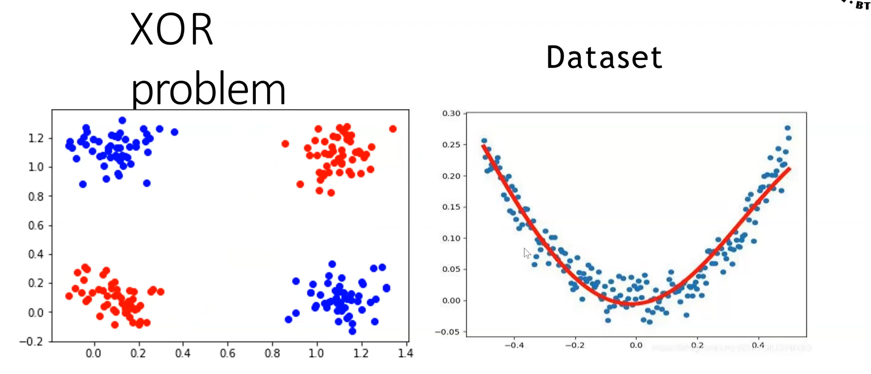

These graphs are not linearly separable. Applying a linear model would cause a lot of residual error.

It is incredibly important to reduce error when trying to create an effective machine learning model.

In some cases your nonlinear relationship can be transformed into a linear relationship by transforming x or y, or both. These are called Transformable nonlinear models.

This is not always possible. When linearity can’t be created (for example: the model involves one or more predictor variables of a higher order than 1), polynomial models are used. They are not preferred as it is incredibly hard to create a good model.

There are also models that are nonlinear in the parameters such as the second picture above.

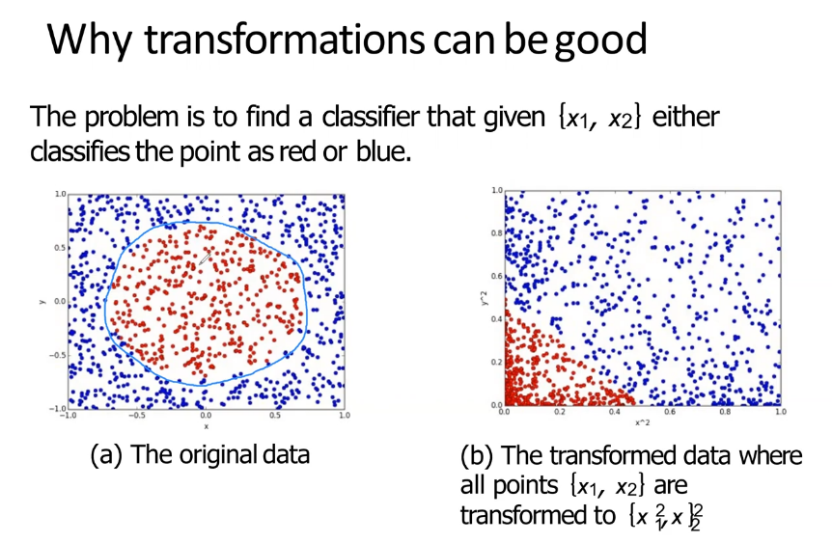

## Classification

Given a set of data, learn a function which predicts y given x where y is categorical. That is the definition of classification. The learned function outputs categorical data.

Example

* Input: Shopping list
* Output: Demographic
* F (x1) = Parent

Classification is one of the most used techniques. You will find it in

* **Datamining**
* Computer vision
* Text mining
* NLP
* Many more…

Classification models need labelled data to train the model. Test data is also required (80% is used to train 20%). You could also divide it in 3 ways: test data (70%), validation data(15%),test data(15%). Labelled data is data which has a “fact sheet” connected to it so the model can learn what is what.

A classification model can either output an instance or probabilistic outcome. Instance gives definite answer whilst probabilistic will give you different likelihoods.

### Example of instant classification

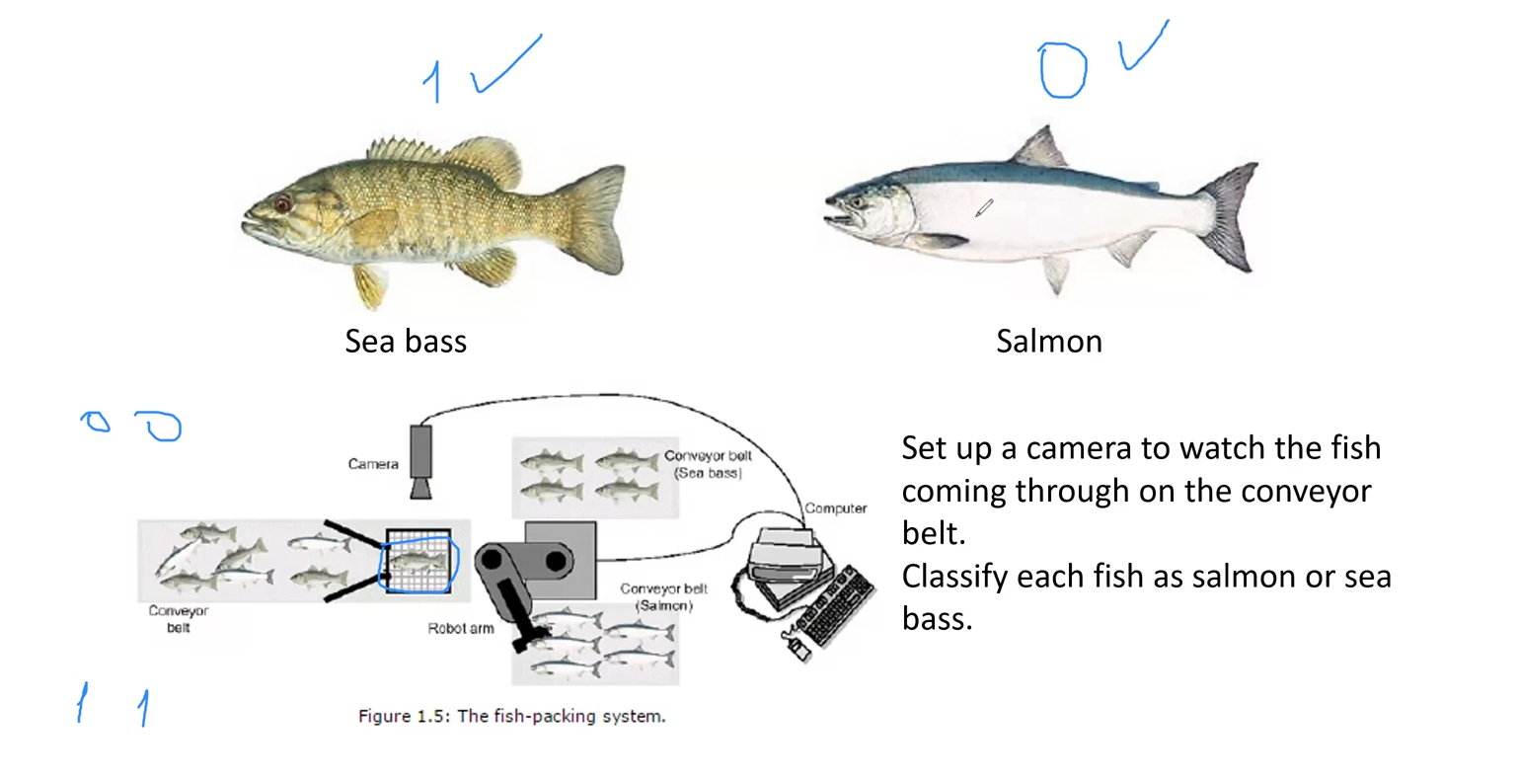

### Example of probablisitic

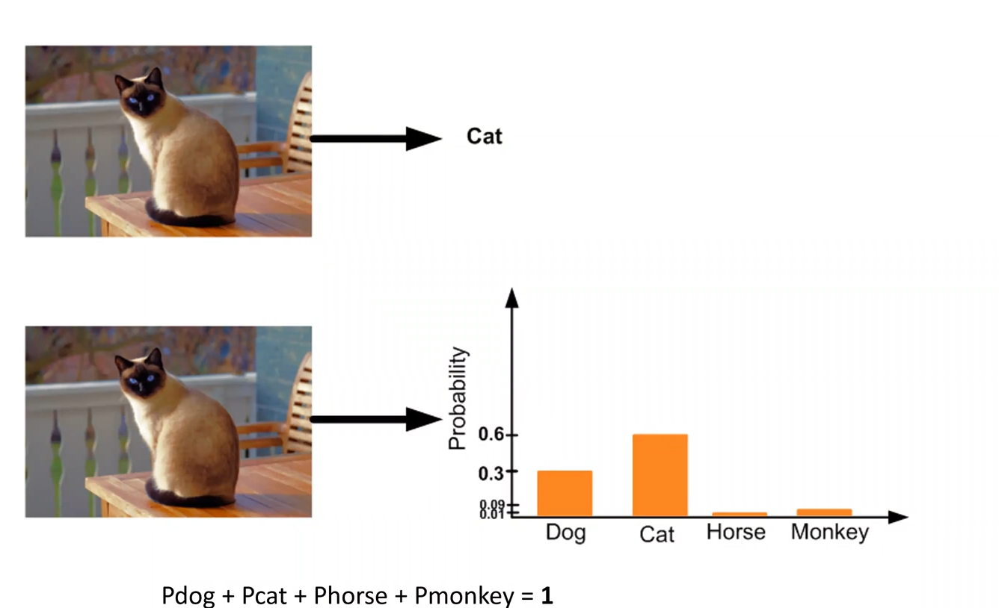

The classifier makes a probabilistic decision based on the image. Since cats and dogs share a lot of similar features, the classifier hedges most of its bets on those two. Most features check out with cats and thus the classifier assumes it is a cat.

### Classifier evaluation

* A positive example classified as positive is called a **true positive**
* A positive example misclassified as negative is called a **false negative**
* A negative example classified as negative is called a **true negative**
* A negative example misclassified as a positive is called a **false positive**

Accuracy is calculated like this

$$\frac{True positives+True negatives}{True positives+False positives+True Negatives+False negatives}$$

A confusion matrix or contingency table can be used.

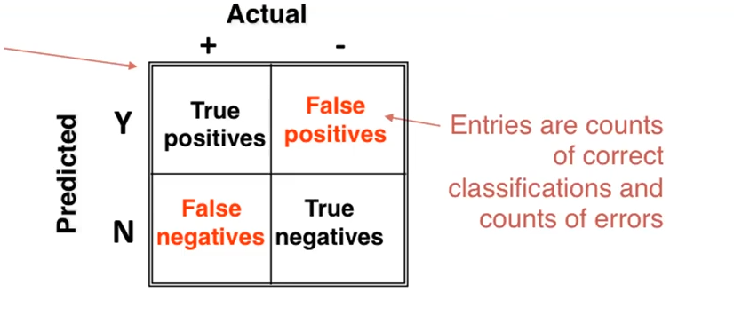

# Unsupervised Learning

## Clustering

Finding groups of objects such that the objects in a group will be similar or related to one another and different from the objects in other groups is clustering.

Clustering is characterised by:

* No a priori class labels
* No knowledge of what is correct
* Attempt to understand how different data points are related to each other
* Greater similarity in a group, greater difference between groups -> better clustering.

Classification tries to fit objects in pre-set groupings, clustering tries to create the groups based on the datapoints available.

Whilst supervised learning has access to class labels, in unsupervised there are no training sets.

Unsupervised doesn’t train a model similar to a supervised model.

Clustering is partitioning of data into subgroups. There are two types of clustering approaches: Hard clustering and soft clustering.

**Hard clustering:**

* Instances belong to only one cluster
* Often heuristic, i.e., provides a good enough cluster solution
* Most common approach

**Soft cluster approaches**

* Instances can belong to several clusters
* Examples of soft clustering is fuzzy clustering and probabilistic clustering methods
* Low error rate
* Hard to create

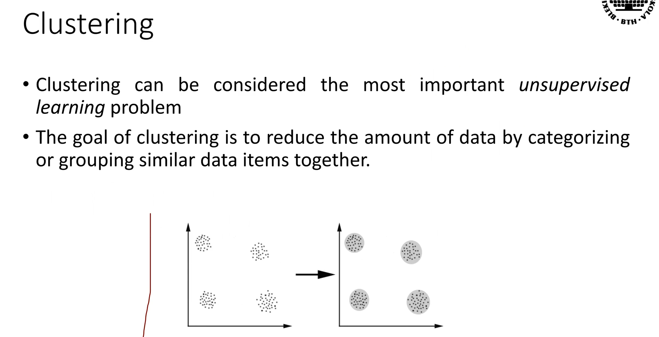

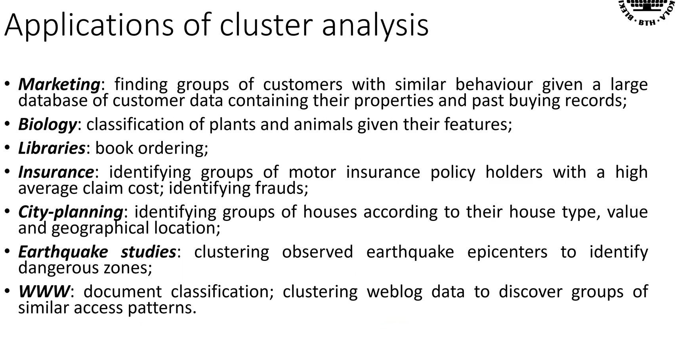

### Major cluster approaches

Partitioning approach

* Construct various partitions and then evaluate them by some criterion, e.g.g, minimizing the sum of square errors
* Typical methods: **K-means**, CLARANS

Hierarchical approach

* Create a hierarchical decomposition of the set of data using some criteria (wtf)
* Typical methods: **hierarchical**, Diana, Agnes

Density based approach

* Based on connectivity and density functions
* Typical methods: **DBSCAN**, OPTICS, DenClue

Probabilistic clustering maximisation

* Come back here.

### General info about clustering

Most algorithms assume there are k number of clusters.

A distance function is often used to compare similarity of instances.

* A distance function defines the distance between two points in a set

There’s no distance function to rule them all. The one you should choose depends on the data and the problem

* Euclidian distance is common when using numerical data
* Jaccard distance, Manhattan distance are alternatives.

# Ensemble learning

Two heads are usually better than one. The idea behind ensemble learning is you’re your machine learning model can be improved by combining more than one machine learning method.

Combination models are generally known as model ensembles.

The main motivations are coming from:

* Computational learning theory
* Statistics

Ensemble learning also allows you to train more than one machine learning method by using the same training data. The models will be slightly different from each other and compensate for each other in some sense.

In essence, ensemble modes in machine learning have the following two things in common:

* They construct multiple diverse predictive models from adapted version of the training data
* They combine the predictions of these models in some way, often by simple averaging or voting

### Example

When you want to buy a new car, will you go directly to a dealership and immediately buy a car solely based on the advice of the dealer? It’s highly unlikely.

You would hopefully search several web pages where people have posted their reviews and compare different car models, checking for their features and price. There’s also a chance that you’d go to several dealerships and ask your friends for recommendations.

As a result, you wouldn’t quickly make a decision, but will make a decision based on a multi-faceted analysis. The opinions can have different strength in influence.

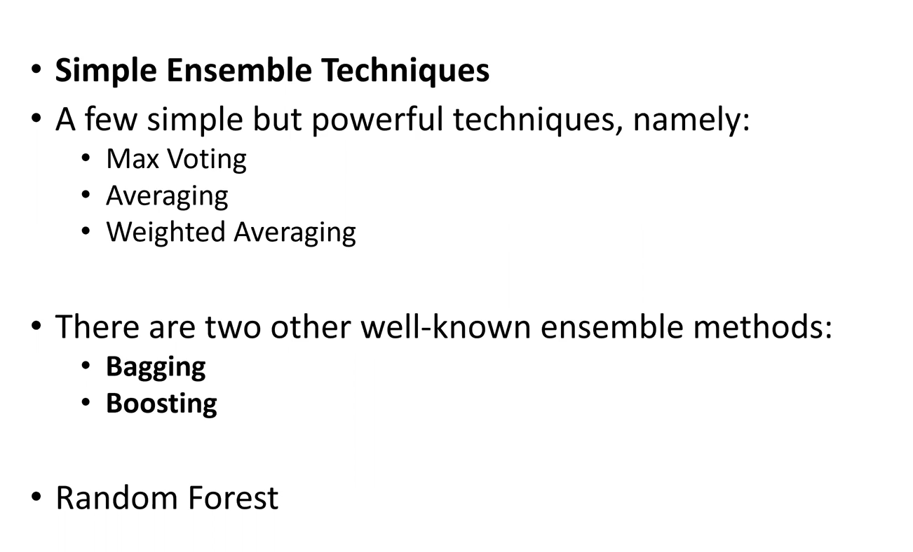

### Chart, diagram Description automatically generatedMax voting

The max voting method is generally used for classification problems.

In this technique multiple models are used to make prediction for each data point

The predictions by each model are considered as a vote. The prediction which we get from the majority of the models are used as the final prediction

### Average voting

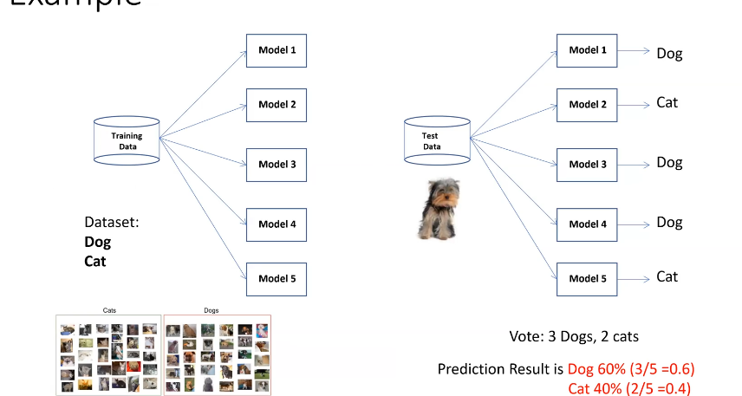Similar to the max voting technique, multiple predictions are made for each data point in averaging.

In this method we take an average of predictions from all the models and use to make the final prediction

Averaging can be used for making predictions in regression problems or wile calculating probabilities for classification problems.

These two methods have models which all rely on the same dataset. This can cause the models to be too similar.

### Bagging

Bagging is a highly effective ensemble method that creates diverse models on different random samples of the original data set.

The samples are taken uniformly with replacement and are known as **bootstrap** samples

Each subset of data of the original data is used to train different model in the ensemble.

Thus, different models will be obtained in the ensemble which is what we want.

The main idea behind bagging is combining the results of multiple models (for instance, all decision trees to get a generalised result.

**Bootstrapping** is sampling technique in which we create subsets of observations from the original data set with replacement.

Multiple subsets are created from the original dataset, selecting observations with replacement. (Replacement means that you can use the same sample point in different sets)

A base model is created on each of these subsets (monke weak, but monke together strong)

The models run in parallel and are independent of each other

The final predictions are determined by combining the predictions from all the methods

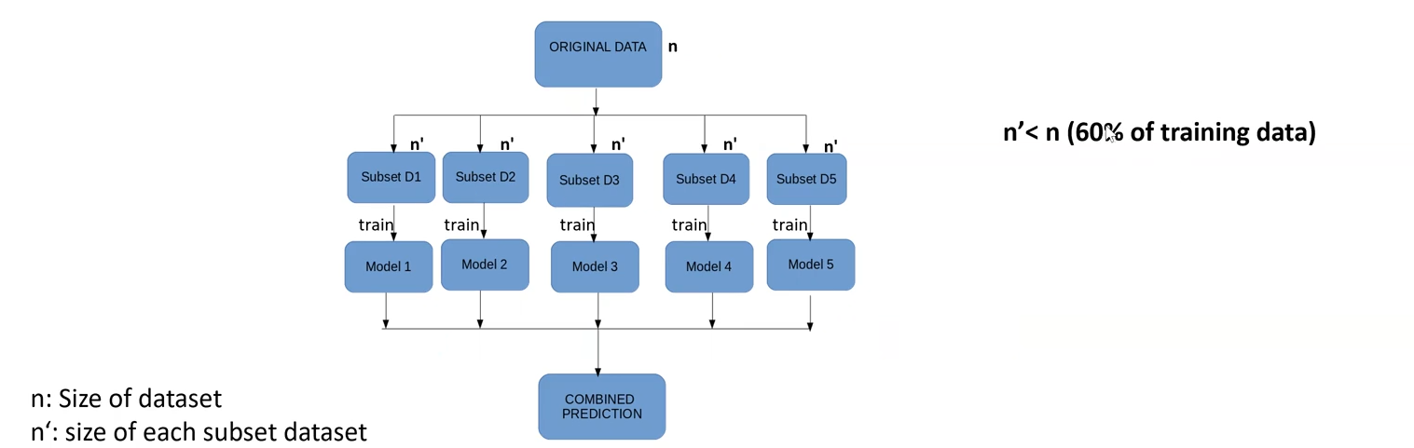

In bagging and bootstrapping, we’re giving each model different training sets to work with, creating diversified models which together work well. They each will pick up some differences based on the training set.

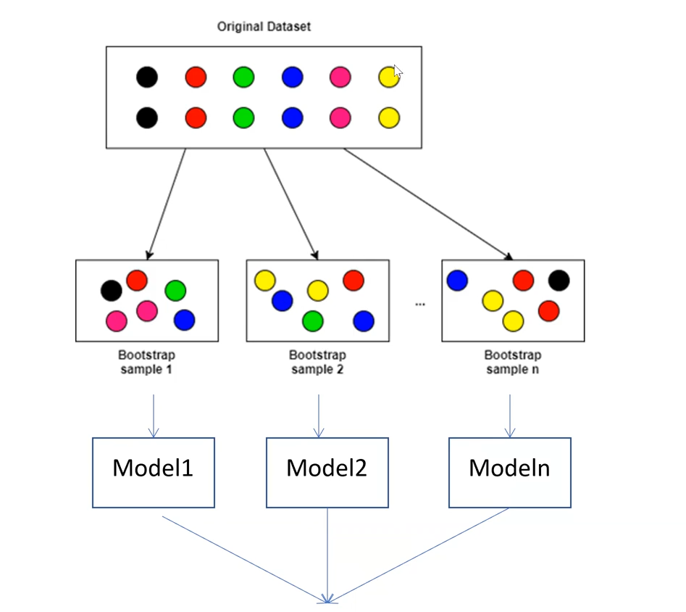

Each model here will identify certain things better than the other.

### Boosting

Boosting is an ensemble technique that is similar to bagging, but uses a more sophisticated technique than bootstrap to create diverse training sets

Boosting is sequential process where each subsequent model attempts to correct the errors of the previous model

The succeeding models are thus dependent on the previous model. If the previous model had problem with x, then the subsequent model will train extra to identify x in essence

# Semi supervised learning.

For many problems, labelled data can be rare or expensive. Unlabelled data is much cheaper.

One technique under supervised is the following:

Let’s say we have some limited labelled data; we train a supervised classifier on said data and have it predicted unlabelled data. We then manually check the newly labelled data, correct the wrong ones, it is then put back into the training set to train a better model.

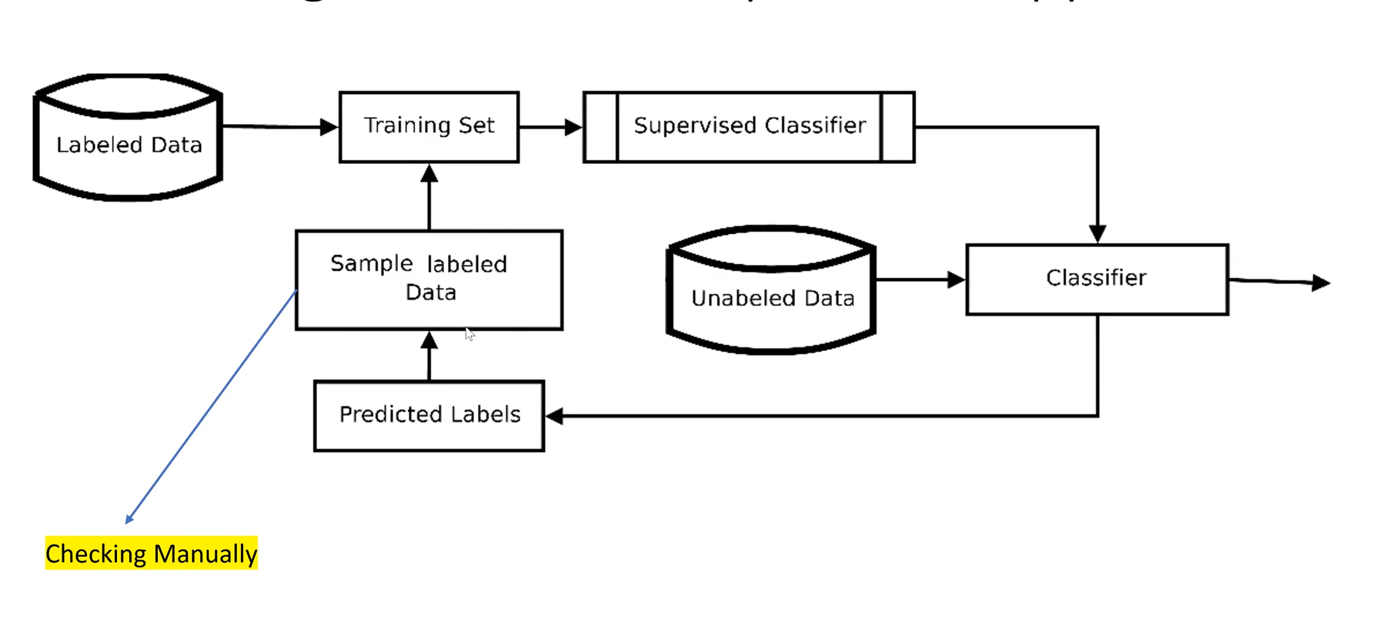

Another technique is:

Apply a clustering method on your data. Manually check if it is sound. Then use it as training data for a supervised learning method. Boom semi supervised learning

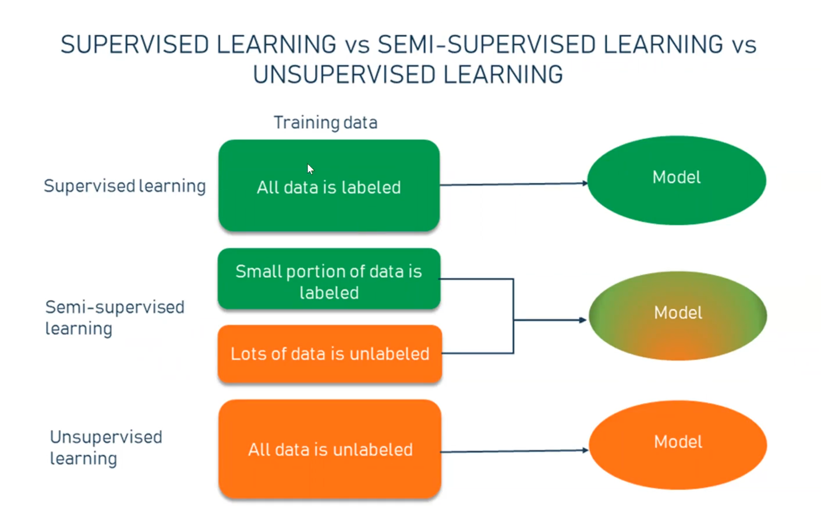

# Reinforcement learning

Learn to take correct actions over time by experience

It is similar to how humans learn, through “trial and error”

The model tries an action

1. “See what” happens
2. “Remember” what happens
3. Use this to change choice of action next time you are in the same situation
4. Converge towards learning the correct action

In reinforcement learning, an emphasis is put on long-term return, not immediate benefit. Some actions may seem not beneficial in the short terms but pay their dividend in the long term.

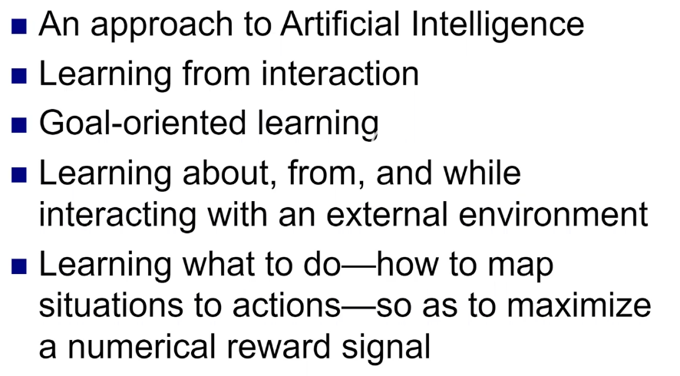

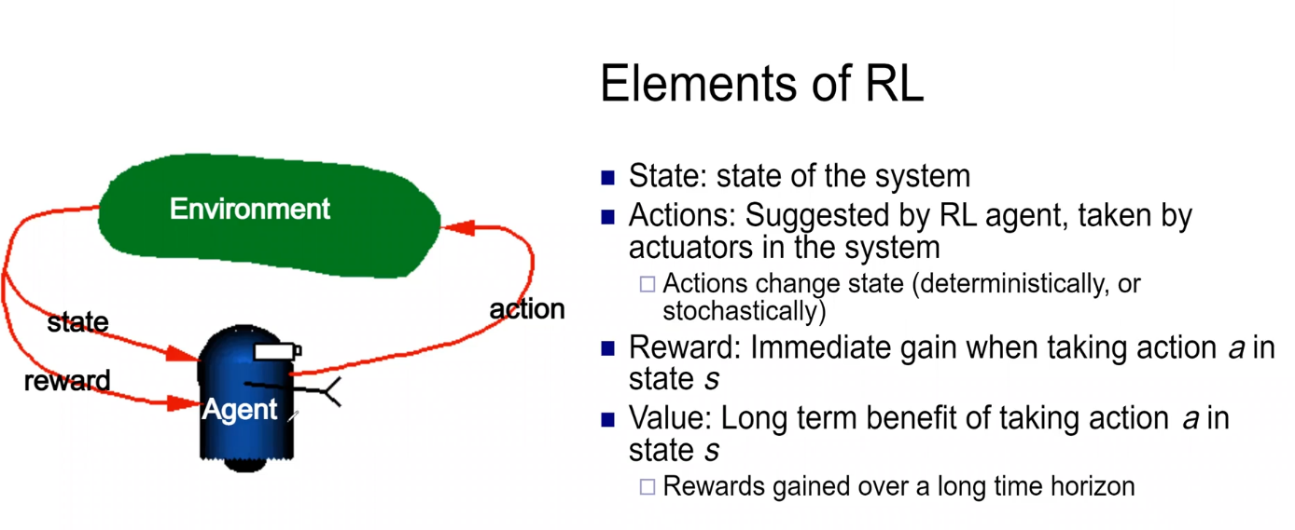

There is no training data. The agent only learns through experience. The objective is to get as many rewards as possible whilst minimizing penalties. Reinforcement learning is very strong but requires a lot of computational power in comparison to other methods.

Lecture 7

# Neural networks

A neural network can be defined as a model of reasoning based on the human brain. (the human brain has about 100 billion neurons)

The brain consists of interconnected set of nerve cells, or basic information processing units, called neurons

Signals are propagated from one neuron to another by complex electrochemical reactions.

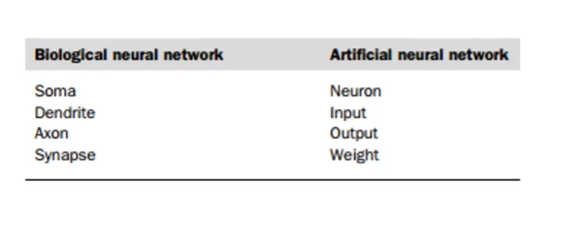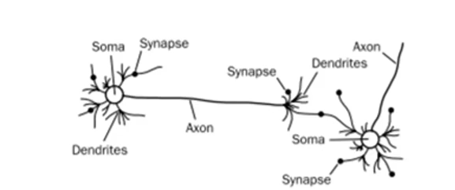

Our brain can be considered as a highly complex, nonlinear and parallel information processing system.

Information is stored and processed in neural network simultaneously throughout the whole network. Rather than at specific locations.

ANNs are capable of learning, that is, they use experience to improve their performance.

## Diagram, engineering drawing Description automatically generatedWhat is a neural network

The neurons are connected by weighted links passing signals from one neuron to another

Each neuron receives a number of input signals through its connections; however, it never produces more than a single output signals.

They are supervised based. You have to train the ANN model. Labelled data is required to train the model. Test data is used to see the performance of the model. It is iteratively trained. You train, test, train test.

# Activation functions used in ANNs

Many activation functions have been proposed but only a few have found practical applications

Their main purpose is to convert an input signal of a node in a ANN to an output signal.

Activation functions are important to avoid using large values in NN

Help the network to use the useful information (decrease noise effect)

There are four common choices: the step, sign, sigmoid and linear function.

The step and sign activation functions are called hard limit functions whilst the other are called soft -||-.

Activation functions activate the necessary neurons for a particular task.

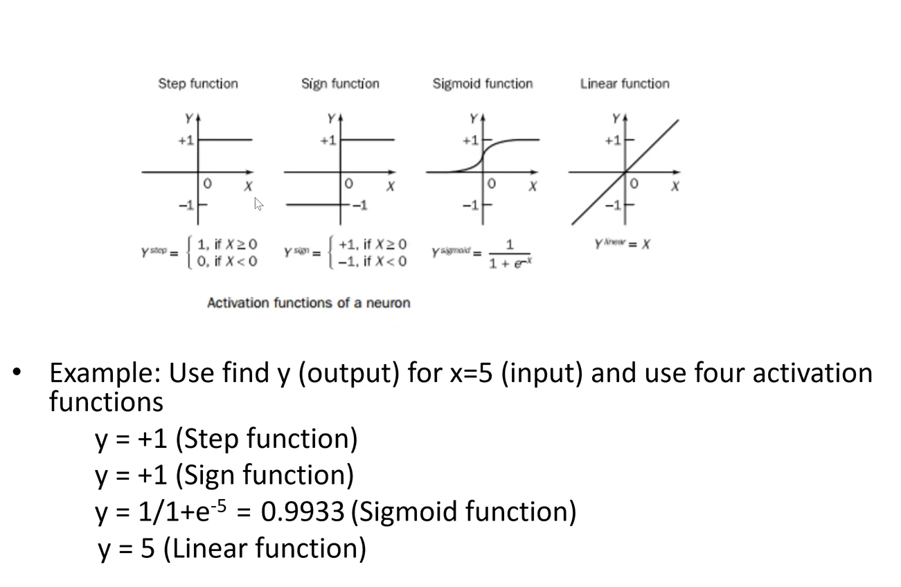

The step and sign function either turn on or turn off a neuron depending on input. Sigmoid and linear change the “importance”

# Perceptron

Is the simplest form of a neural network (equivalent to a brain with one neuron)

Perceptron is a linear classifier.

Consists of a single neuron with adjustable weights and bias

A neuron receives several signals from its input links, computes a new activation level and sends it as an output signal through the output link(s)

The input signal can be raw data or outputs from other neurons

The output signal can either be a final solution to the problem or an input to other neurons 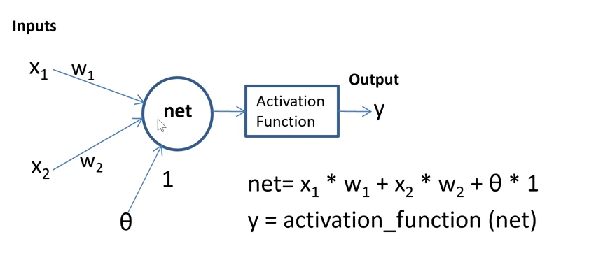

A perceptron with two inputs, one bias and an output. The bias neuron allows the decision boundary to be adjusted

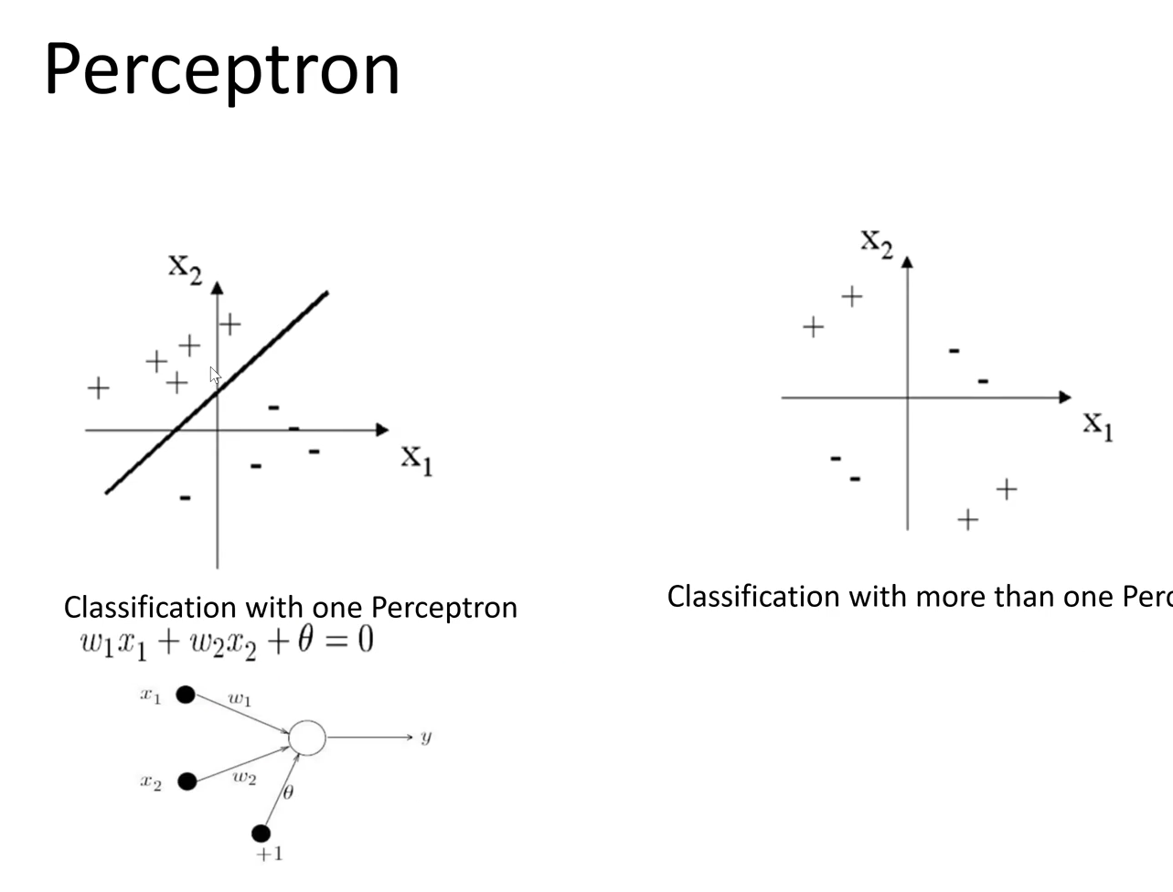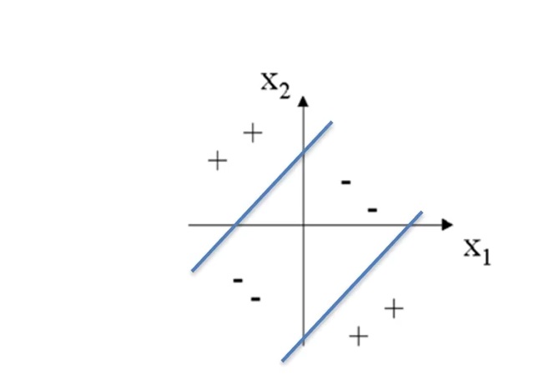

The second picture can’t be solved with one perceptron.

### How does a perceptron learn its classification task

By updating weights, reducing the difference between the actual and desired outputs of the perceptron iteratively. This iterative model is called backpropagation.

## Gradient descent

All you need to know is that gradient descent is used to adjust weights and bias.

There are three well known gradient descent methods applied to Ann and deep learning methods

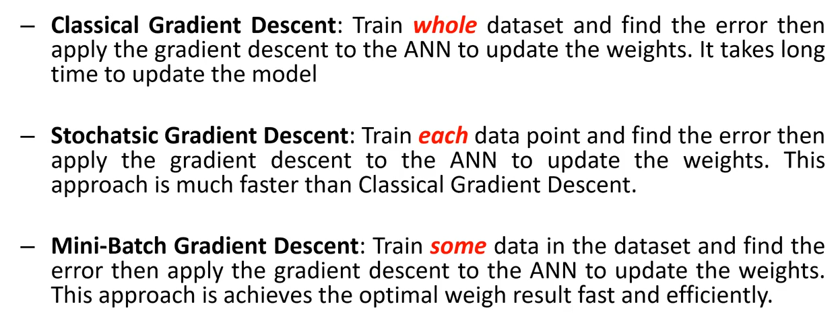

Stochastic is not effective.

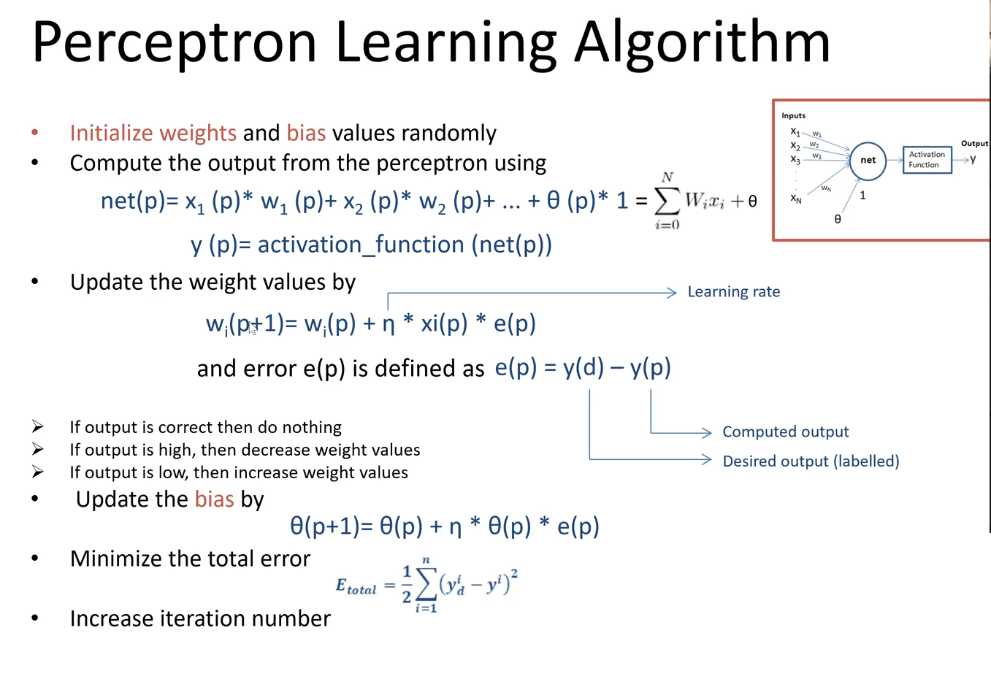

# Multilayer neural networks

Multilayer neural networks are more complex neural network models than the single perceptron model. These network models consist of several perceptrons. They have an input layer, hidden layer(s) and output layer. Learning algorithm is based on feed forward and backpropagation.

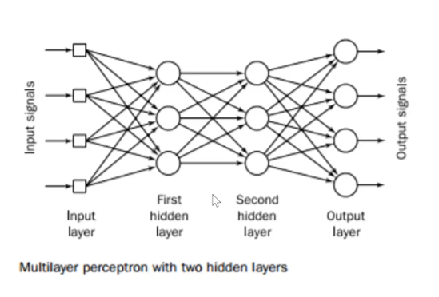

The ideal number of hidden layers are anything lower than 8.

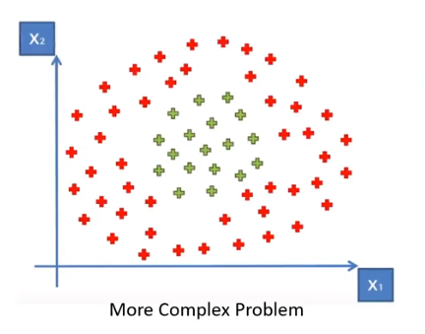 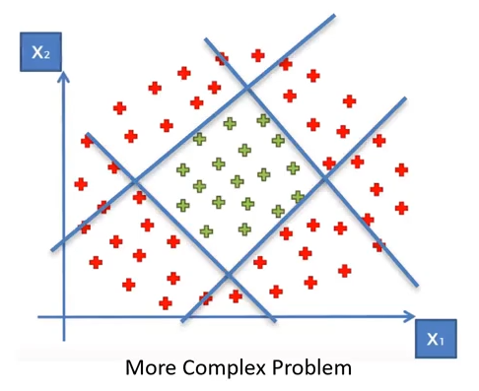

If we want our model to classify something like this, a single perceptron will not suffice. We need more perceptron’s.

A multilayer perceptron is a feedforward neural network with one or more hidden layers. Typically the network consists of an input layer of source neurons at least one middle or hidden layer of computational neuron and an output layer of computational neurons.

The input signals are propagated in a forward direction on a layer-by-layer basis

### Hidden layer

Why is a middle layer in a multilayer network called a hidden layer. What does this layer hide?

* A hidden layer hides the desired the output
* Neurons in the hidden layer cannot be observed through the input/output behaviour of the network
* There is no obvious way to know what the desired output of the hidden layer should be

Neurons in the hidden layer detect the feature; the weights of the neurons represent the feature hidden in the input patterns.

These features are then used by the output layer in determining the output pattern.

### Feedforward neural network

A feedforward neural network is an artificial neural network wherein connections between the units do not form a cycle. The outputs are always sent to the next layer. Data enters at the input and passes through the network layer by layer, until it arrives at the outputs.

During normal operation, that is when it acts as a classifier, there is no feedback between layers. This is why they are all called feedforward.

### Backpropagation learning

To derive the back propagation learning law let us consider the three-layer network shown below.

Input signals x1; x2;…;xn are propagated through the network from left to right whilst error signals e1;e2;…;em are sent from right to left

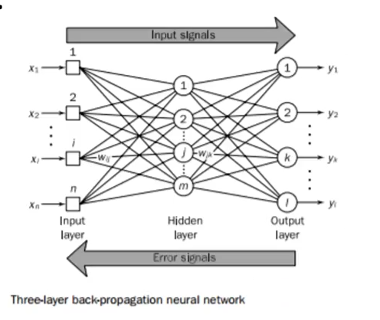

To propagate error signals, we start at the output layer and work backward to the hidden layer. Error is estimated by subtracting desired and actual outputs. The weights are updated accordingly. Feed forward is used to find the desired result whilst back propagation is used to update the neurons.

# Recurrent neural networks

A recurrent neural network (RNN) is a class of artificial neural network.

A standard feed-forward neural network computes its output values in a sequential input-process-output manner.

Unlike feed forward neural networks, RNNs can use their internal state (memory) to process sequences of inputs.

RNNS are very powerful because they combine two properties

* Distributed hidden state that allows them to store a lot of information about the past efficiently
* Non-linear dynamics that allow them to update their hidden state in complicated ways

With enough neurons and time, RNNs can compute anything that can be computed by your computer.

RNNS hold past data and not only the current data. Increasing its efficiency.

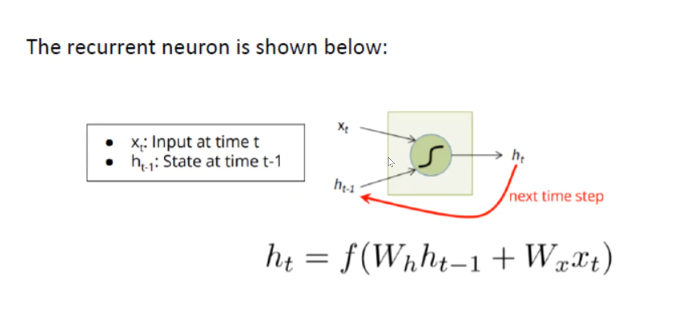

Past data is used as input in the current calculation.

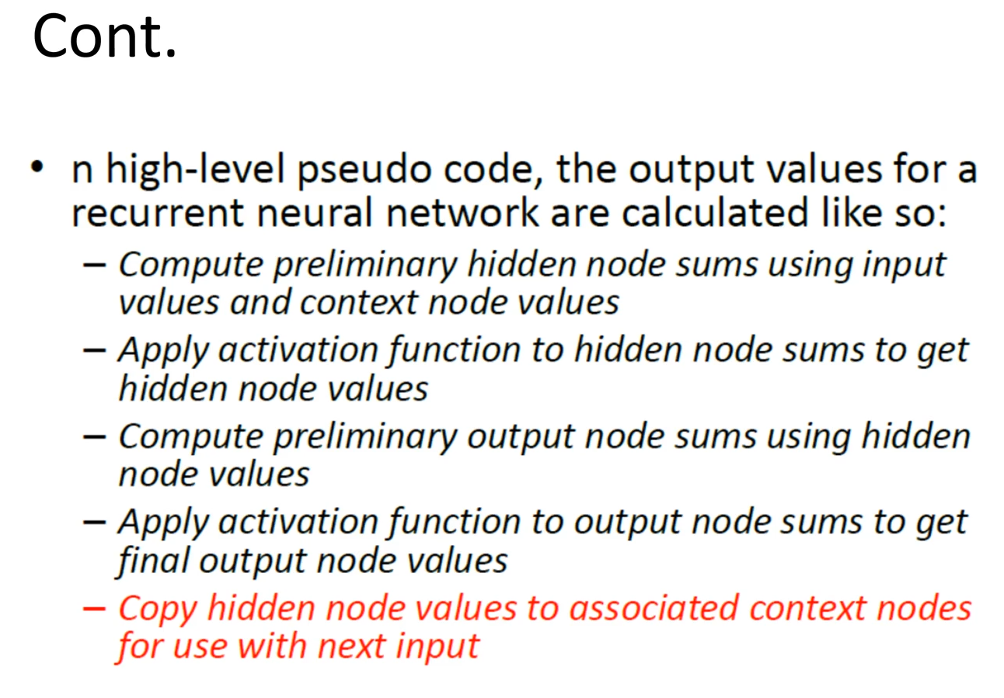

## Elman and Jordan RNN

In the Elman RNN, the hidden layer has a complementary layer of the same number of neurons in said layer called a state layer. The state layer contains retains memory of the prior hidden layer result.

Jordan on the other hand, holds information about the output layer instead of maintaining the history of the output layer

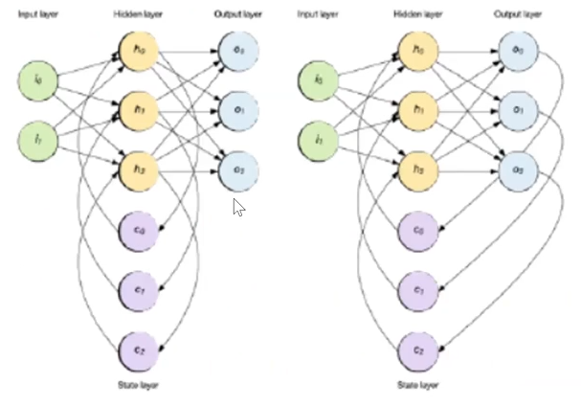

Left is Elman: The purple layers are the state layers.

Elman keeps information from the hidden layer, whilst Jordan keeps the information from the output layer.

# Deep learning

Deep learning is a branch of machine learning inspired by the functionality of the human brain called neurons

In deep learning artificial neural networks similar to human neurons are used for learning and predictions

All information in deep learning passes through these artificial neural networks The ultimate goal of deep learning is to make machine think like humans.

In normal neural networks you can’t have 15 hidden layers without a major hit in performance.

### Deep learning process

A manual definition of features is not required to train deep learning algorithms

They create a unique features and models of their own

To train a deep learning method, you give it raw data and the deep learning model does feature extraction on its own. Labelled data is still required.

### Machine learning contra deep learning

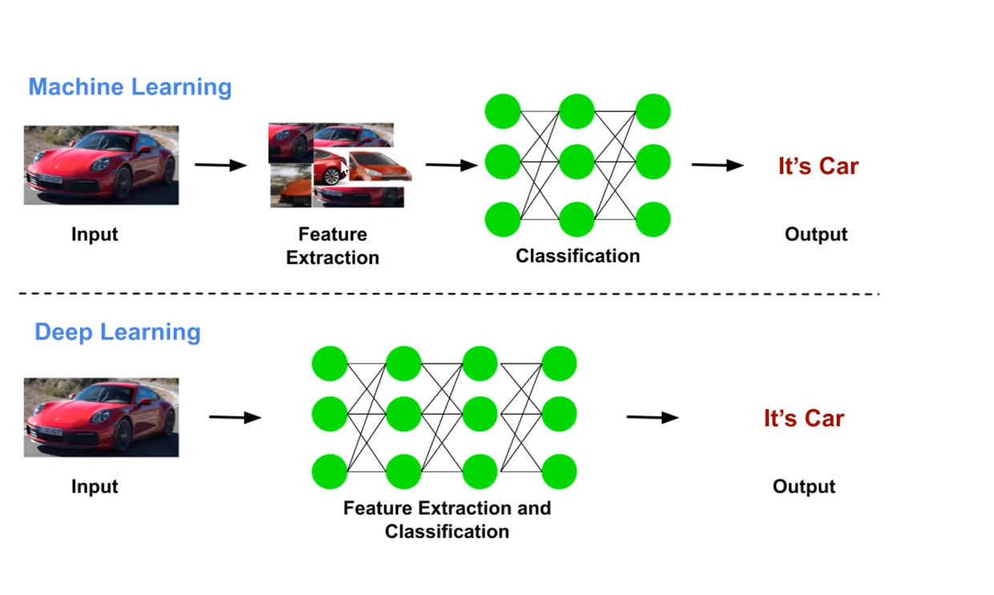

* Deep learning is a subset of machine learning
* In ANN users need to define the features in the available data whereas in deep learning, deep learning algorithms identify data features automatically.
* Small and medium data sets are enough to train ANN algorithms. Whereas in deep learning lots of labelled data is required to train deep learning methods
* Can work on low-end machine. Deep learning requires high computing power
* Few minutes to hours to train ANN methods. Few days or weeks to train deep learning methods.
* Accuracy is good using ANN methods. Accuracy is very high using deep learning
* methods.
* Development cost is low for ANN methods. However, development cost is high for dl methods.

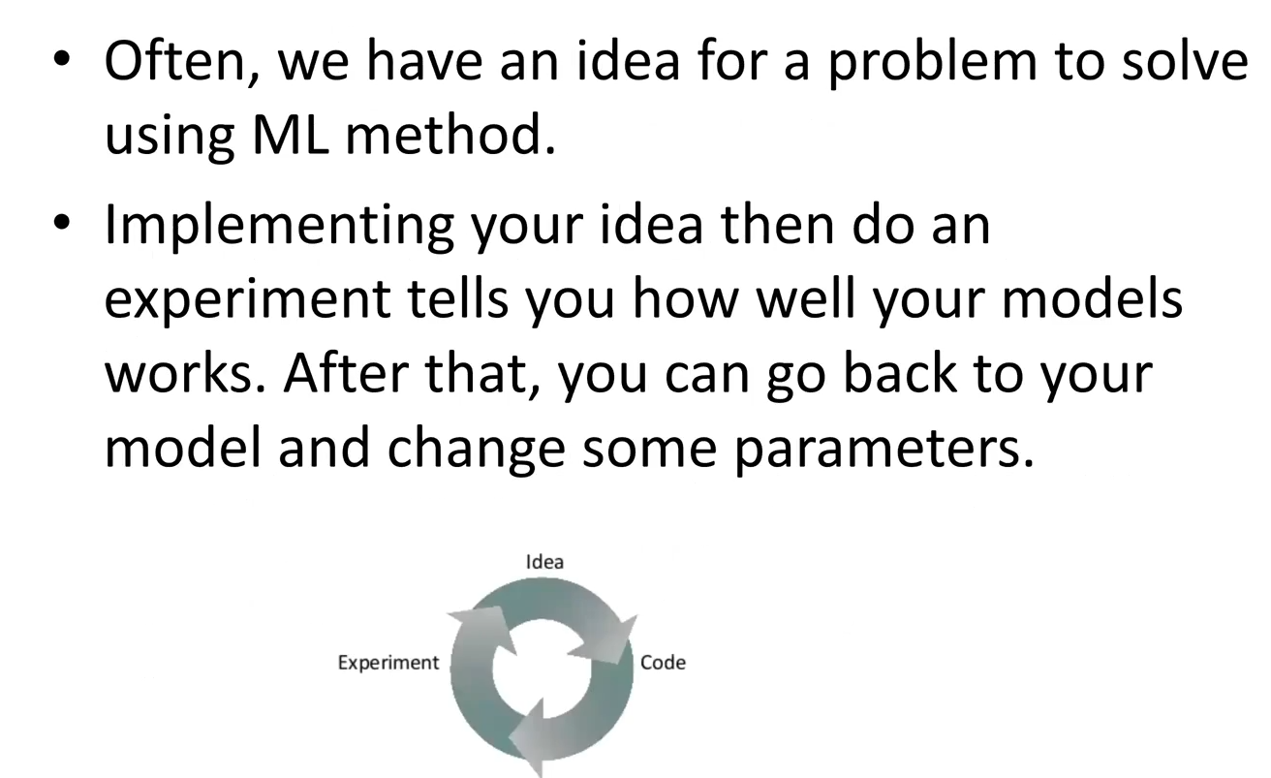

# Convolutional neural networks.

Convolution is used extract features. It is then sent to a fully connected NN to do the classification.

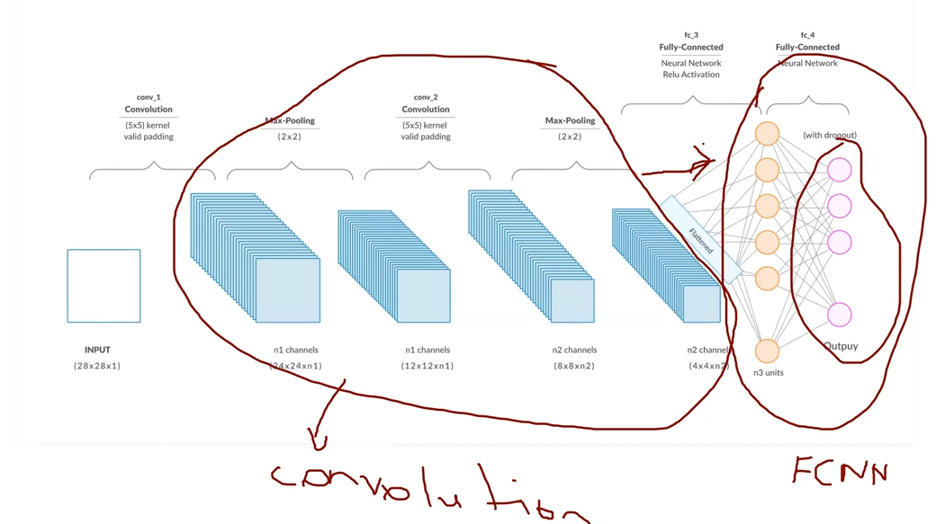

CNN are very similar to ordinary NN

They are also made up of neurons that have learnable weights and biases.

**STEPS in CNN:**

* Input
* Convolutional layer
* Rectified linear units
* Pooling layer
* Fully connected layer (NN)
* SoftMax layer.

### Convolutional layer

Imagine that we have an image. A filter/kernel of any size (2x2, 3x3 etc) and moves around the image to find features.

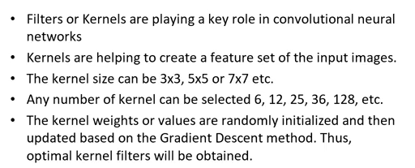

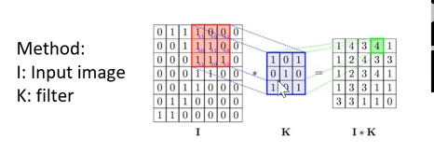

The filter finds the features and creates the resulting matrix.

Strides and padding.

There are 2 main parameters we can change to modify the behaviour of each layer.

After we choose the number of filters and filter size we also have to choose the stride and the padding

Stride controls how the filter convolves around the input volume. In the example, the filter convolves around the input volume by shifting with by the assigned value.

Padding adds 0’s around the frame of your input volume

### Pool layer

Performs a down sampling operation along the spatial dimension width, height

Maxpooling being the most popular another is the averaging pool layer

This layer drastically reduces the spatial dimension.

This layer also assumes the most important features have the highest values. Let’s say we have these features; it goes around and extracts the most important features from the matrix/image.

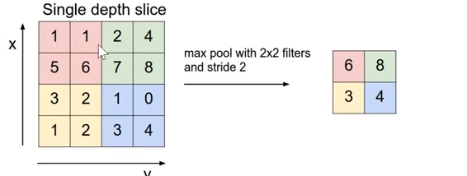

Basically, goes around, takes the max or average of the 2x2 filter, and discards all other values.

### SoftMax function

Provides probability of the output events

The SoftMax function takes an unnormalized vector and normalises it into a probability distribution.

SoftMax is often used in neural networks to map the non-normalized output to a probability.

### ReLU

The purpose of ReLU is to introduce nonlinearity

In the past nonlinear functions like linear and sigmoid were used, but researchers found out that ReLU layers work much better. The network is able to train faster without giving up any significant amount of accuracy.

The ReLU layer applies the function f(0, x) to all of the values in the input volume, in basic terms this layer just changes the negative activations to 0

ReLU increases the nonlinear properties of the model.

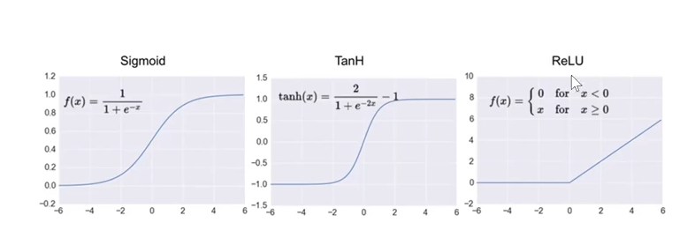

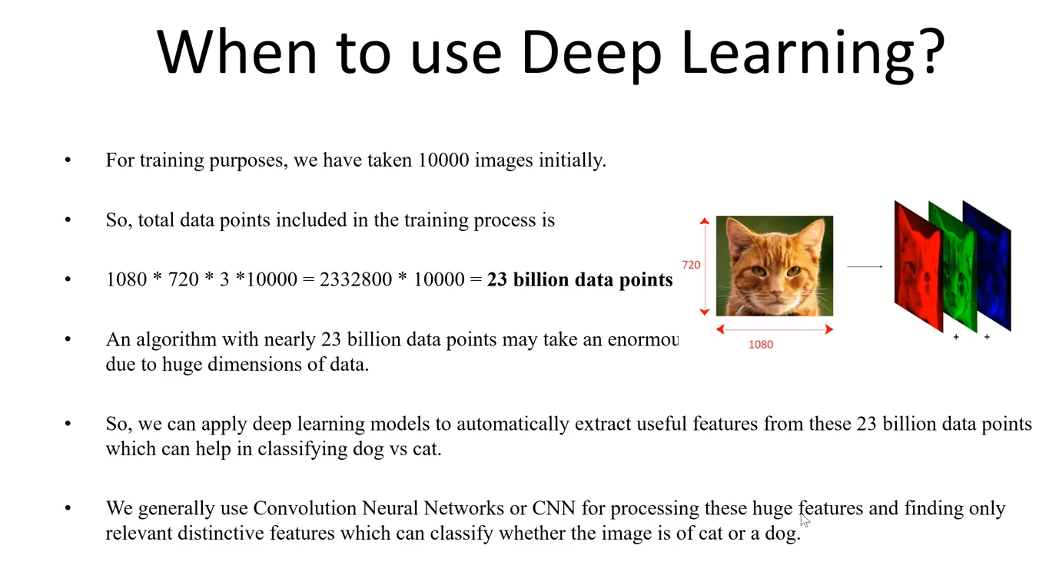

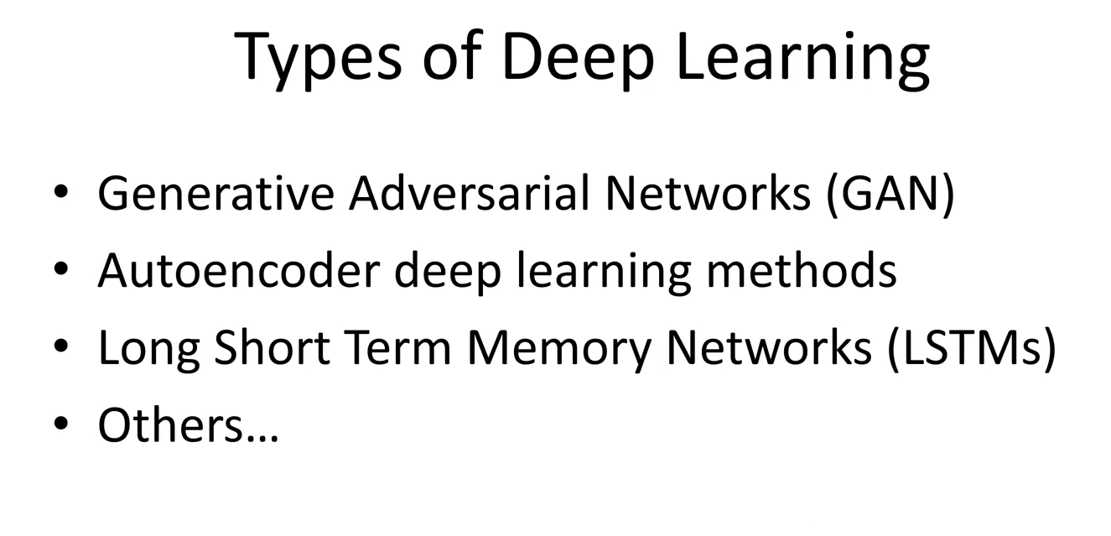

Lecture 8

# Computer vision

Computer vision is the science and technology of machines that see and extract the meaning from the images. It has been used in different applications such as image understanding, security, machine vision, robot vision image analysis, video understanding (and video has sequence of images or lots of pictures) etc.

Computer vision allows extends the ability of humans in areas which are currently unavailable for us. We can’t go to mars and latency is a huge problem but with the help of computer vision we can explore mars.

An image allows us to describe a thousand things. The goal of computer vision is to extract useful information.

There is a spectrum of supervision

Unsupervised, weakly supervised, and fully supervised.

This depends on the amount of labelled data used.

### Applications

Digit recognition, license plate readers, face and other biometric recognition.

Handwritten recognition is a very important area. Many old documents suffer from one or another problem which makes them hard to digitize. Computer vision helps with this, but it is challenging. Handwritten recognition allows immortalising of historic records.

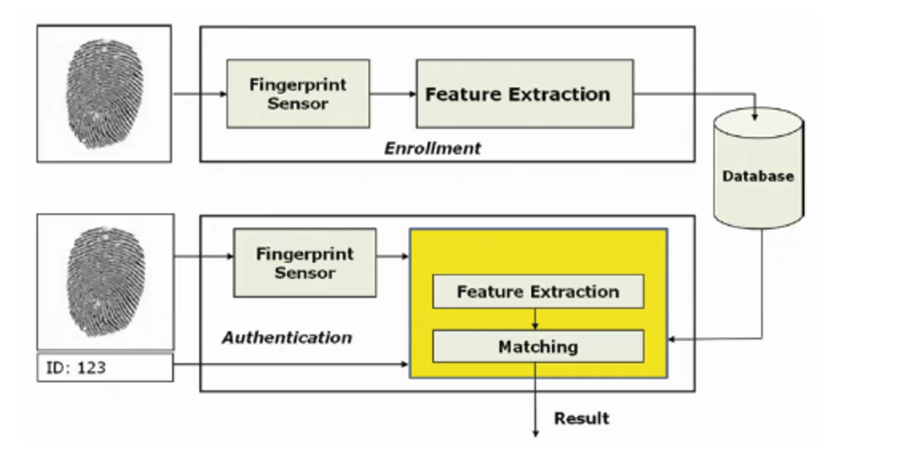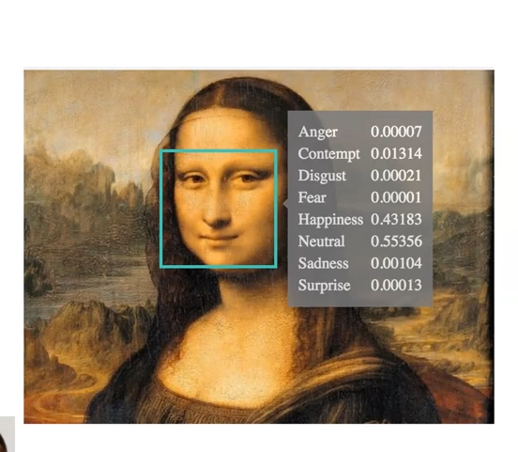

A block diagram of fingerprint recognition.

Emotion recognition is also becoming more popular

## What is an image

An image is a 2-dimensional function with a set of I (x, y) intensity values along with image coordinates.

The amplitude of the I is called intensity or grey level at the point (x, y)

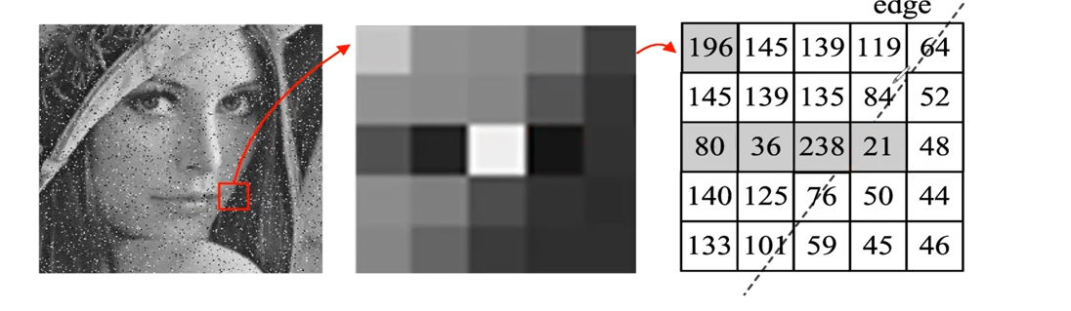



### Other image types

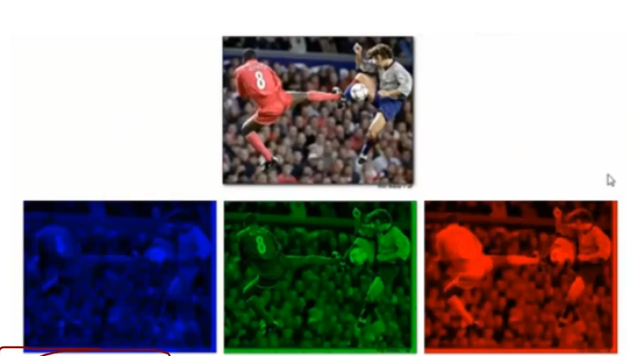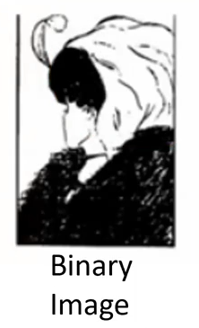

RGB consists of three 2-dimensional images put together

A binary image is an image where the intensity value of each coordinate is either 1 or 0 (black or white).

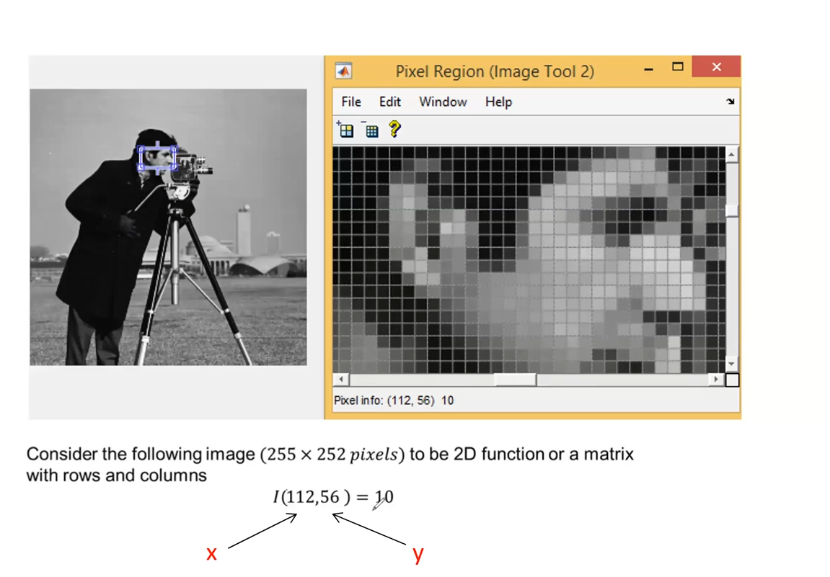

### Why is computer vision difficult?

Images come with varying problems and different forms. A few things which could cause problems is

* Contrast
* Noise
* Resolution
* Blur
* Motion
* Compression

Every image has some of these features, to train an AI to decipher things despite its imperfections causes issues. A car which is blurry might be hard to identify whilst a noisy car is just fine for one algorithm. The cars could be the same but be classified as completely different things.

## Most popular problems in computer vision

### Image classification with localisation.

Given an entire image, identify a specific thing.

Example

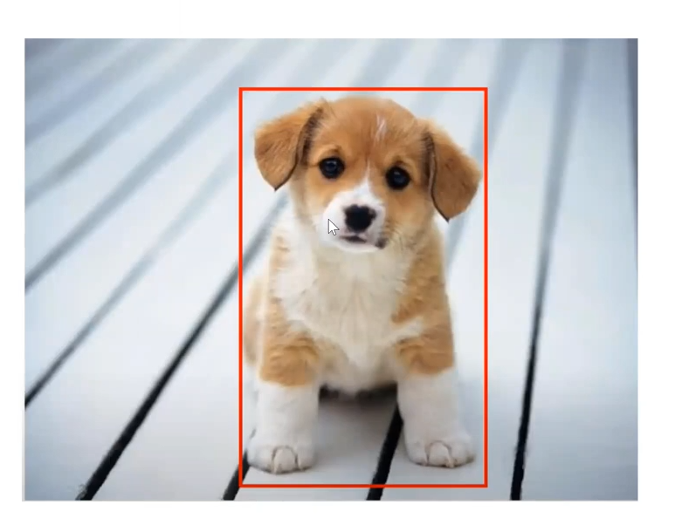 Is this a dog and where is it?

### Object detection in images

Assume that we have multiple objects in an image. Rectangles are drawn around each object and localize them. This is called object detection.

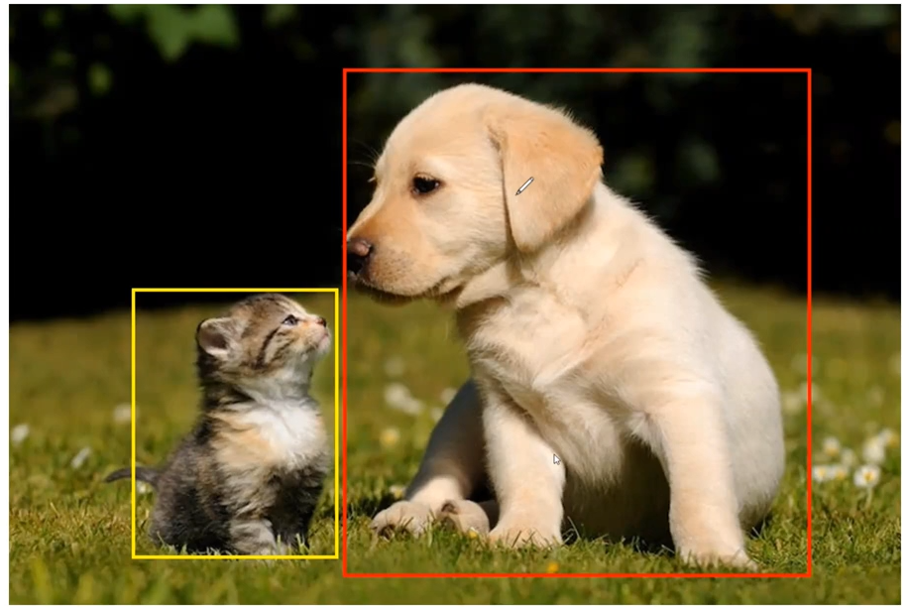

## Image segmentation

Another important subject in within computer vision is image segmentation.

It is the process of dividing an image into different regions based on the characteristics of pixels to identify objects or boundaries to simplify an image and more efficiently analyse it.

Segmentation is used in several domains, from filmmaking to medicine. Image segmentation is also used to track objects in a sequence of images and to classify terrains, like petroleum reserves in satellite images.

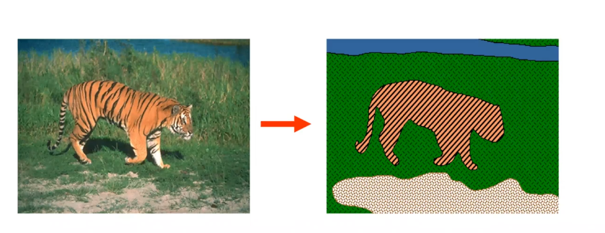

One way to view segmentation is as clustering. Where pixels sharing certain features such as colour intensity or texture are grouped together and represented as a single entity.

Example usage in the film industry

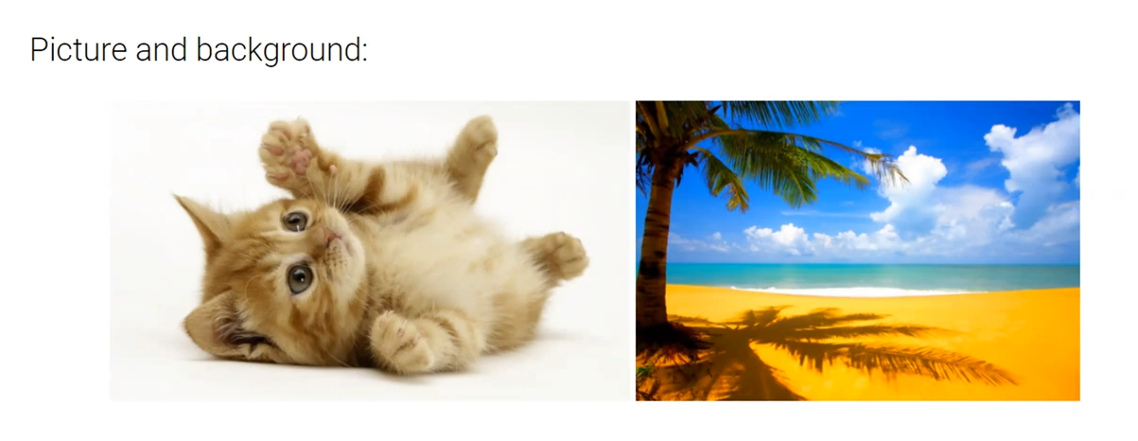 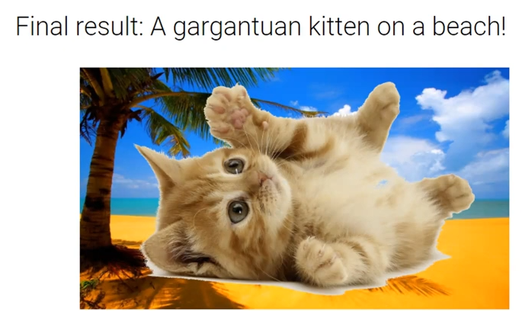

The first picture is segmented into background and kitten. The kitten can then be put on the beach background. It is not perfect but it is a simple and efficient technique. Algorithms to improve segmentation are being developed constantly. Photoshop magic selection uses this.

### Types of image segmentation.

**Semantic segmentation** is an approach detecting for every pixel belonging class of the object. For example, when all people in a figure are segmented as one and background as one object.

**Instance segmentation** is an approach that identifies for every pixel a belonging instance of the object. It detects each distinct object of interest in the image, for example, when each person in a picture is segmented as an individual object. Instance segmentation is object recognition along with segmentation.

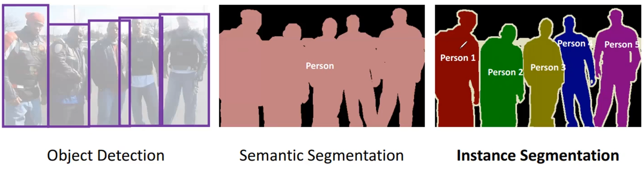

Note how object detection gives a bounding box. Segmentation selects the pixels belonging to each object.

### The difference between Image recognition, semantic segmentation, object detection, and instance segmentation

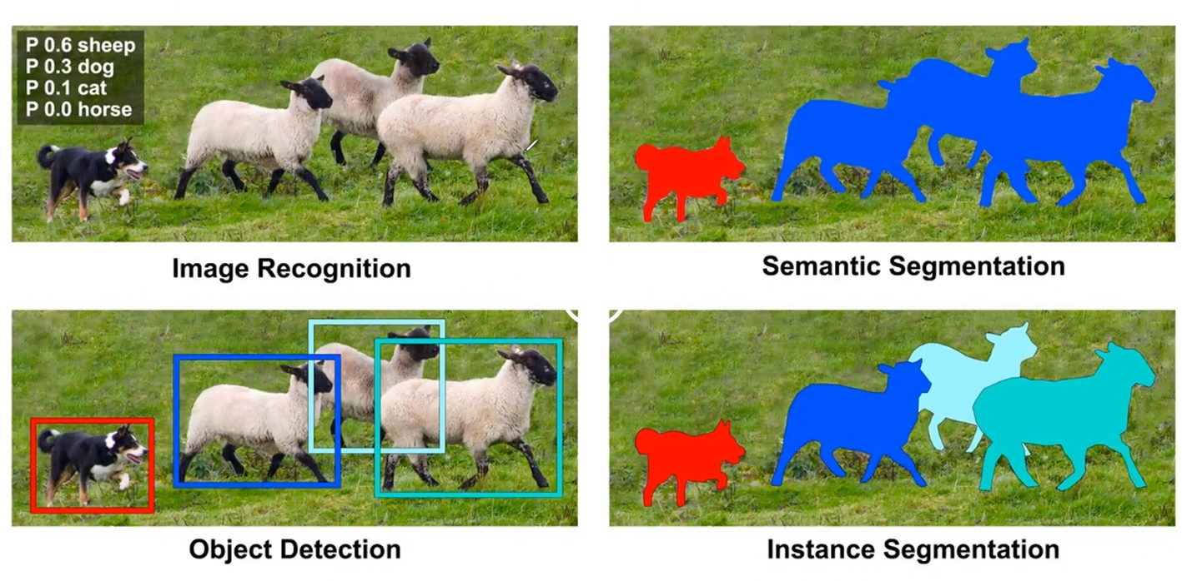

Image recognition identifies the objects as dogs and sheep.

Semantic segmentation classifies the pixels of different objects in separate groups (the dog group and sheep group). No identification of the objects are done

Object detection localizes the different objects.

Instance segmentation does classification of the object. Each object is put in its own pixel group.

### Pattern recognition

A pattern is an object process or event that can be given a name.

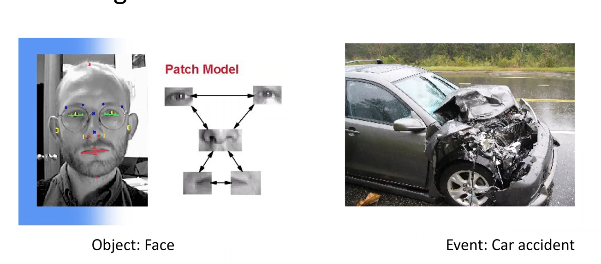

Feature extraction can either be done through traditional means or be automated through CNN.

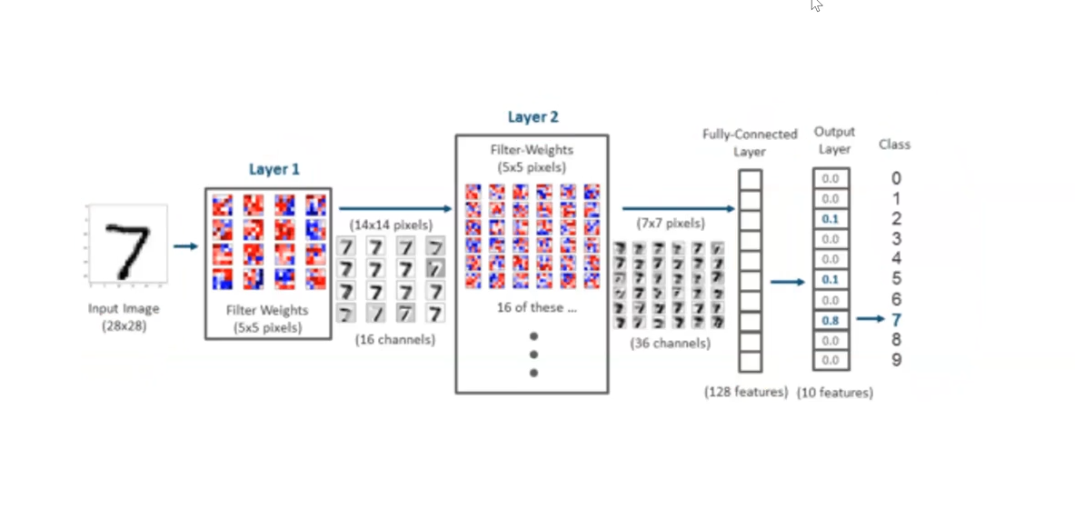

Several convolution layers are strung togther to get the features which are sent to the fully connected layer.

# Natural language processing

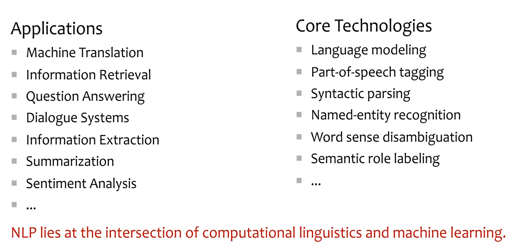

A good example is auto correct, text to audio, audio to text machine translates.

### Challenges in translation

What fragments?

How to make it efficient

Fluency vs fidelity.

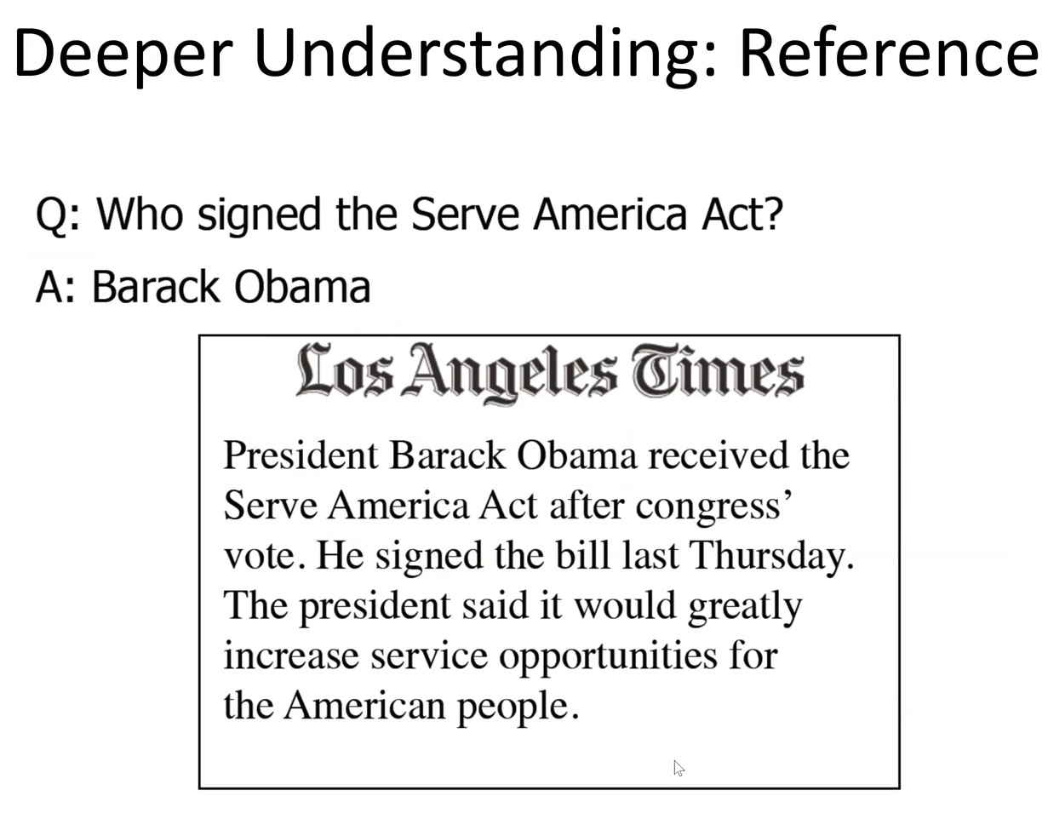

### Why is NLP hard?

* Ambiguity  
  Word senses: bank (finance or river)

Part of speech: chair (noun or verb)

* Scale
* Sparsity

The frequency of different words in a large text corpus. Some words are used far more often than others, creating difficulties in teaching your AI the usage of those less common words.

* Variation
* Expressivity  
  Not only can one form have different meanings, but the same meaning can be expressed with different forms.

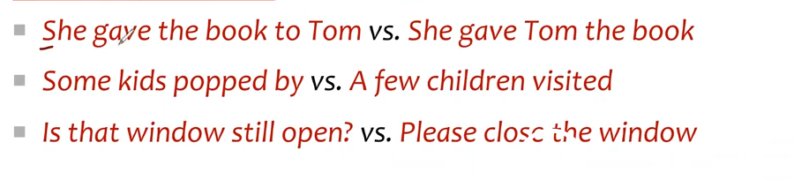

* Unmodeled variables

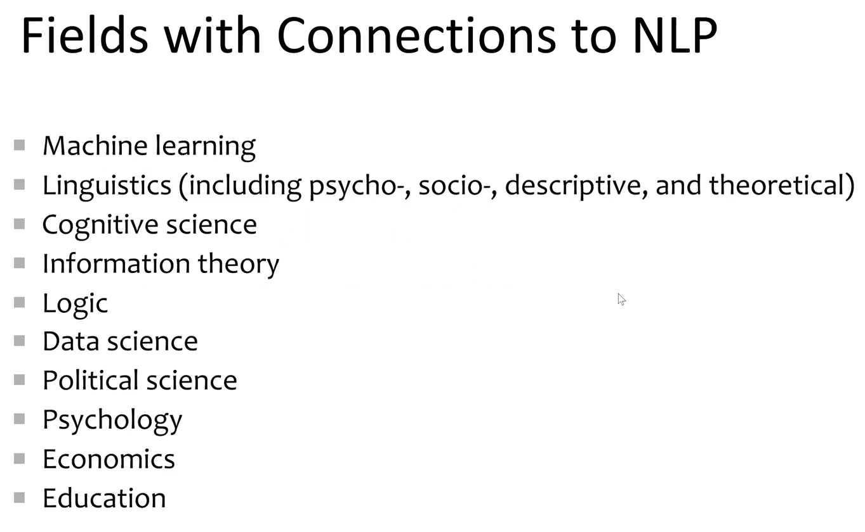 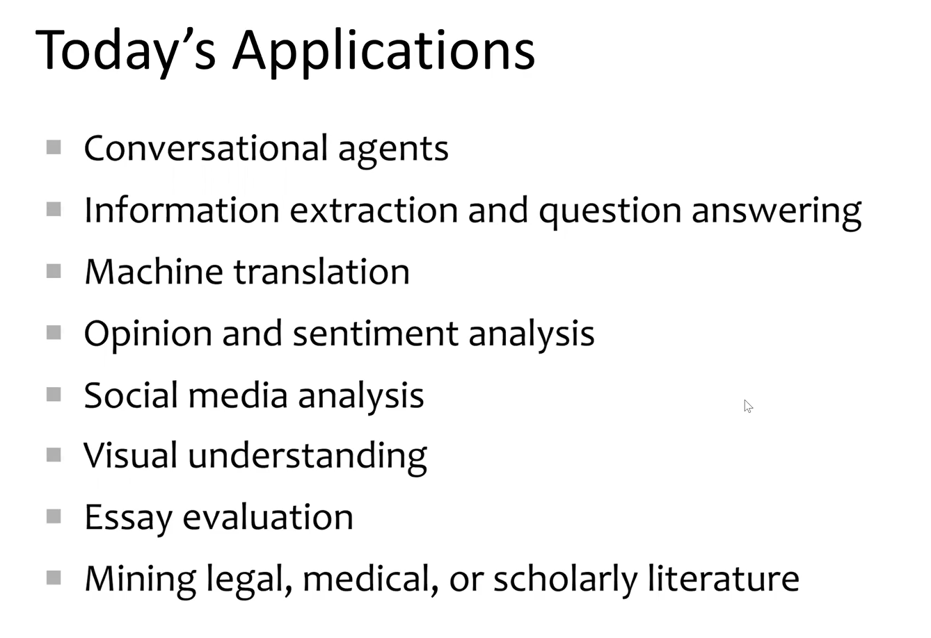

Lecture 9

# Ethics

## The rise of fake media and disinformation: Will AI make this worse?

Ai systems are getting really good at creating fake images, videos, conversations, and all manner of content.

We already have trouble believing everything we hear, see and read

What happens when you can no longer tell if an image is real or ai generated or if you’re talking to a bot or a real person?

Once shared and re-tweeted with others this news starts to go viral, whether it is true or not, the damage is irreversible.

Ai can be very dangerous in this sense. The creation of misinformation will only be worsened with the rise of AI.

### How to avoid fake media

Crosscheck your news with other sources.

Currently, AI’s are being developed which can see if it is a doctored or AI generated media.

## Creating transparency in AI decision making

There are many approaches used in AI however no algorithm has reinvigorated the AI market quite like deep learning.

Algorithms such as deep learning is a black box. We aren’t really sure how deep learning works and this can be a big problem when we rely on this technology to make critical decisions such as loan applications, who gets paroled, and who gets hired.

AI systems that are unexplainable should not be acceptable, especially in high risk situations.

In response, the advent of explainable AI is slowly being developed. AI in which its “thought process” can be articulated. The algorithms are readable by humans and articulable.

Deep learning relies heavily on training data

People wrongly assume that the training data is always clean, from a large pool, and represents society as a whole but results have proved this is not the case. Our data reflects the society in which we exist, with all its prejudices and injustices.

If we are going to use Ai algorithms to make any sort of worthwhile decision, we must demand that it is able to explain itself.

### What kind of transparency is needed in AI algorithms?

What factors does it consider when deciding.

## Will intelligent machines have rights?

### Questions

As machines become more intelligent and we ask more and more of our machines, how should they be treated and viewed in society?

Once machines can actually simulate emotion and act similar to human beings, how should they be governed?

Should we consider machines as humans animals or inanimate objects?

To what level do we ascribe liability and responsibility to the devices themselves over the people that are supposedly in control of them?

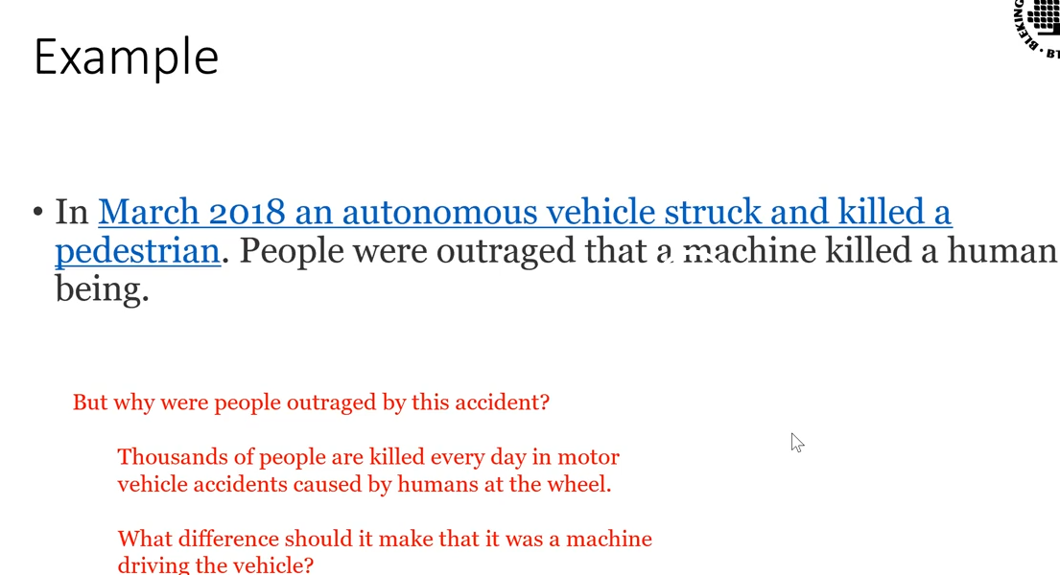

The reason for this outrage is because society hasn’t and may never accept when a machine kills a human. However, the likelihood of cutting all traffic related fatalities is almost certainly impossible.

As such if we want autonomous vehicles on the road this scenario will happen again, and again. Despite perhaps dramatic evidence that machine driven vehicles have overall far lower fatality rates than human driven vehicles the issue of liability and control is primarily one of those ethics

So, we need to be asking these questions, figuring out what we can accept and what is ethical, and put laws and regulations in place now to safeguard against future tragedies.

## Beneficial use & capacity for good

The main purpose of AI is to help people, make human life easier and better.

Ai helps people in different ways, AI is beneficial. Autocorrect is a simple example.

Additional intelligence will likely proved improvements in nearly every field of human endeavour, including for example, archaeology biomedical research, communication, data analytics, resource management, energy efficiency.

As just one concrete example of a benefit from AI, some farm equipment now has computer system capable of visually identifying weeds and spaying them with tiny targeted doses of herbicide. This not only protects the environment by reducing the use of chemicals on crops but it also protects human health by reducing exposure to these chemicals.

## Malicious use & capacity for evil.

A perfectly well functioning technology, such as a nuclear weapon can, when put to its intended use cause immense evil

Artificial intelligence, like human intelligence, will/can be used maliciously

For example, AI-powered surveillance is already widespread in both proper context (airport-security and camera), perhaps inappropriate ones (products with always on microphones in our homes, and conclusively inappropriate ones (products which help authoritarian regimes identify and oppress their citizens). Other nefarious examples can include AI-assisted computer-hacking and lethal autonomous weapons systems, (LAWS) aka killer robots

Militaries are working on these technologies right now. Because of this forbidding and banning on certain types of technologies would be the most prudent solution.

### Is it possible to stop this?

Hussein says no. Robots have no conscience and only goal is to maximise their reward. This makes them ideal for the military.

## Unemployment/ lack of purpose & meaning

Many people have already perceived that AI will be a threat to certain categories of jobs.

Indeed, automation of industry has been a major contributing factor in job losses since the beginning of the industrial revolution.

AI will simply extend this trend to more fields, including fields that have been traditionally thought of as being safer from automation, for example law, medicine and education.

It is not clear what new careers unemployed people will be able to do.

Attached to the concern for employment is the concern for how humanity spends its time and what makes a life well spent.

Vilket magiskt system. En minskning i mängden arbete som måste utföras orsakar rädsla och leder till fattigdom för tusentals. 10/10

## Environmental effects

Machine learning models require enormous amounts of energy to train, so much energy that the cost can run into the tens of millions of dollars or more.

Needless to say, if this energy is coming from fossil fuels, this is a large negative impact on climate change, not to mention being harmful at other points in the hydrocarbon supply chain.

AI algorithms can also make electrical distribution and use much more efficient as well as working on solving problems in biodiversity environmental research resource management, etc. AI is in some very basic ways a technology focused on efficiency, and energy efficiency is one that its capabilities can be directed.

On balance it looks like AI could be a net positive for the environment but only if it is actually directed towards that positive end and not just towards consuming energy for other uses.

### How can AI be used for decreasing environmental effects

* AI can be used to detect changes in our world through satellite images.
  + Changes in lake size
  + Forest fire
  + Mitigate damage through early detection of catastrophes

### How can AI be used in improving the environment

## Automating ethics

One strength of AI is that it can automate decision making thus lowering the burden on humans and speeding up – potentially greatly speeding up some kinds of decision making processes. However, this automation of decision making will present huge problems for society, because these automated decisions are good, society will benefit, but if they are bad, society will be harmed.

As Ai agents are given more powers to make decisions, they will need to have ethical standards of some sort encoded into them

* There is simply no way around it: The ethical decision making process might be as simple as following a program to fairly distribute a benefit, wherein the decision is made by humans and executed by the algorithms, but it also might entail much more detailed ethical analysis, even if humans would prefer that it did not – this is because AI will operate so much faster than humans can, that under some circumstances humans will e left out of the loop of control due to human slowness
* This already occurs with cyberattacks, and high frequency trading (both of which are filled with ethical questions which are typically ignored) and it will only get worse as AI expands its in society

**Since AI can be so powerful, the ethical standards we give to it better be good**

# Future of AI

1. Safer roads  
   Self autonomous vehicles will become reality
2. Body enhancements  
   Reduce the disadvantages of disabilities. Electronic body parts such as arms and legs
3. Unlimited virtual assistance
4. Increased Safety  
   surveillance systems
5. New jobs and industries

